ECE 3235 Electronics II
Experiment # 5

Frequency response of a CMOS common-source amplifier

Updated on 10/11/12
Note: you might want to bring calculator to the lab

1. Objective
There are two objectives to this experiment. One is to expose you to the very difficult problem of transistor sizing for analog circuit design (do not worry: we will just have a glimpse of it). In contrast to digital circuit design, transistors in analog circuits typically have a very large range of sizes. Getting the right sizes are very important to circuit operation. For example, as you know, you need to have correct DC biasing in order to have transistors work in saturation region. Easy to say, but it is a difficult task. Even in the case of a single stage amplifier. (This is also one main reason that why analog circuit design is so special and analog designers are so precious in the markets). The other object is to simulate the -3dB bandwidths and compare it to your theoretical calculations.

2. Procedure

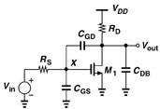
Figure 1. A Common-Source Single Stage Amplifier in CMOS transistors
The above Figure 1 shows a common-source single stage amplifier in CMOS transistors. The circuit topology is very similar to the one we discussed in class (Page 500 in the book). One slight modification is that we replaced the current source with a resistor RD. Note that the three capacitors Cgs, Cgd and Cdb are parasitic capacitors, so please do NOT include them in your schematic design in Cadence. They are simply drawn to help you identify the parasitic components that affect the frequency response of the common source amplifiers. So, the task to conduct frequency response of the circuit in the follow several stages.
1 ) draw the circuit schematic in Cadence

Here, we will use an industry commercial CMOS circuit design technology called TSMC (Taiwan Semiconductor Manufacturing Company) 0.25um technology. To do that, type the following command from a terminal prompt:

cp –rf /zpool1/research/thua/ece3235_test/tsmc025pdk ~/cadence/

Again, please note from Lab 4, the label “~” stands for the home directory, the directory where you are once you log into the system. For example, suppose your login name is “xxx0033”, then “~” should stand for “/zpool1/usra/ece3235/fall10/xxx0033”. You an type “pwd” in the command window to verify (pwd shows the current directory).

After you type in the above command, you should see a directory named tsmc025pdk under ~/cadence. Your model file will be there in the sub-directory models. To build up circuits, you need to include the technology files in the cds.lib file. Now open cds.lib using the text editor (by click documents on the desktop and go to ~/cadence). Add the following line at the end of the file:

DEFINE tsmc25rf ~/cadence/tsmc025pdk/tsmc25rf
Then close the file.

Important note:
(1) If you are also in ECE4311 VLSI Design, please do not type the above two commands, since you should already have it in your directory.

(2) If you have trouble using UNIX commands, please type the commands under TA’s supervision.

(3) After you copy the files, go to ~/cadence directory and start Cadence software by typing virtuoso & at the command prompt. You should see a new library called tsmc25rf when you open Library Manager. If not, please ask help from TA.

(4) Now, use what you have learned from Lab 4 to create a new library called lab5 and then create a cell called common-source-amplifier. Make the schematic for the cell as shown in the following figure:

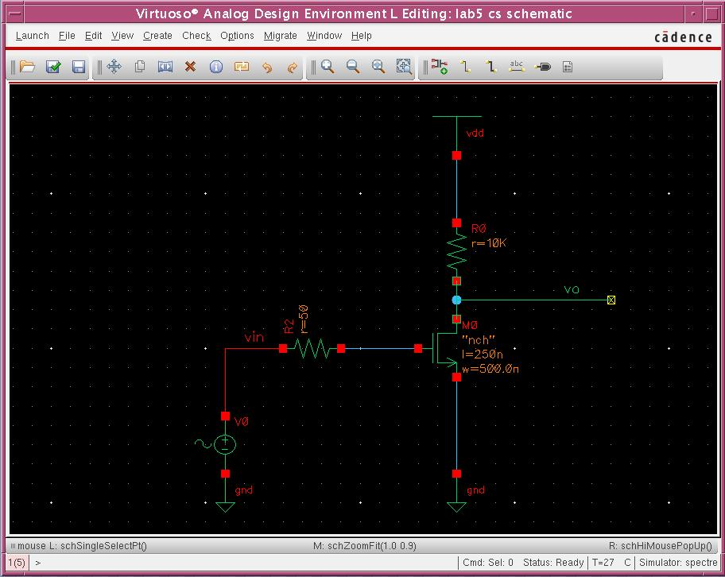

To simplify the amplifier design for you, set Rs=50Ohm and RD=10kOhm. For the input voltage source, put in a VSIN block from analogLib. Please enter its properties including DC voltage and AC magnitude. For example, you can set DC voltage to 0.65V and AC magnitude to 1V.

How to set up the NMOS transistor is explained as follows. Since you need a NMOS transistor, you will need to select the symbol of nmos from analogLib. Put in the initial values for the nmos as shown below:

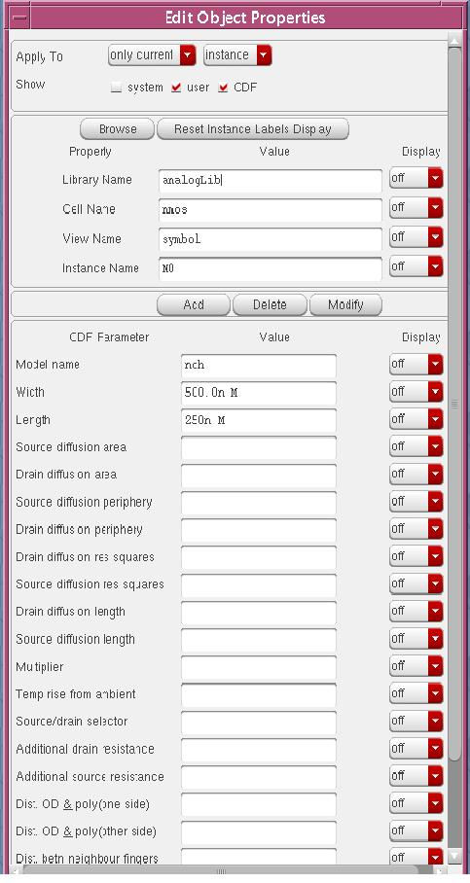
Be sure to set the field of Model name to nch.
(5) for the power supply vdd, select vdd from analogLib. Now properly wire up your circuit.
(6) a warning may be issued after you check and save your schematic. Basically, it is saying that the output node does not connect to a load or simply floats. You can neglect it.
(7) when you are ready to simulate your circuit, open Analog Design Environment (refer to last lab on how to do that). Compared to the last lab, here we need to make some changes. First, you only need to set up DC and AC analysis, not Transient analysis. Then, properly select the input and output to be plotted so that the window looks like this:
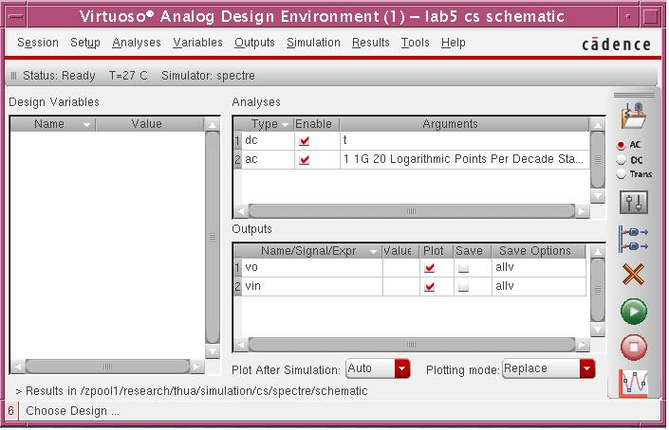
Second, set up your model as shown below
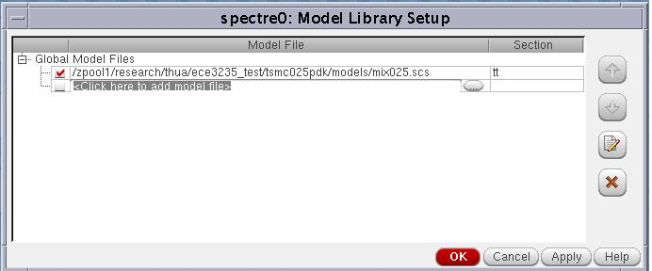

Make sure you specify tt in the section field, otherwise there will be an error.

(8) we will need to specify the voltage value for the vdd symbol we used in the schematic. To do that, select setup➔stimuli… from the Analog Design Environment (ADE) window, then a new window pops up. Select Global sources for the stimulus type, then another window appears. Set the field as shown below:

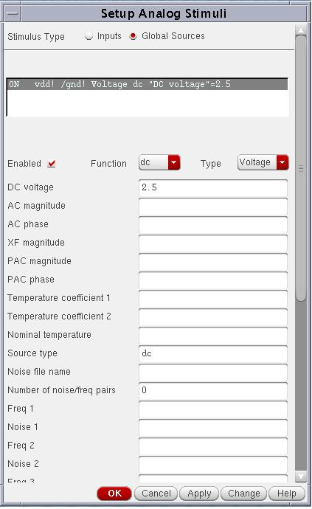

Be sure to enable it. What we did is to set the voltage vdd in the schematic window to 2.5V.

(9) now you are ready to run the simulation. Try that out. You expect to see the output plot like this:

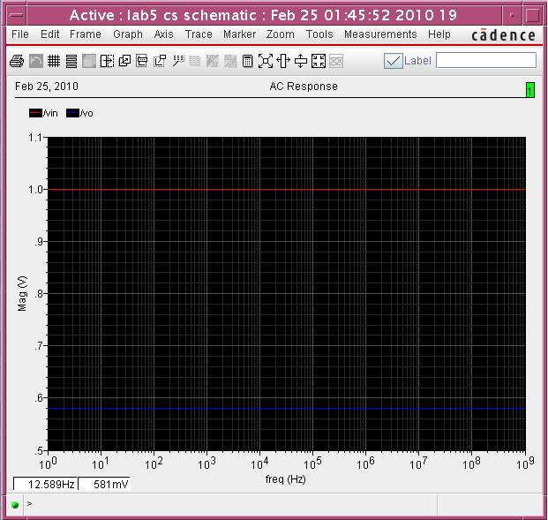

Pause a second to think about what this plot means? If you agree, the gain of the amplifier now is only about 0.58, too small.

In case of any simulation error, please check your circuit and ask TA if you need help. Only proceed to the next section after you can run the simulation correctly.

2 ) design the amplifier for -3dB bandwidth

If you run simulation correctly, you should obtain a plot of input and output as a function of frequency as shown above. However, the gain is so small, which does not represent a good amplifier. Therefore, you will need to re-size the NMOS transistor length and width so that a large gain can be obtained, say larger than 15. (Hint: the range of width is 0.5u to 100u and that for length is 0.25u to 1.25u. Do not forget the unit u which stands for micron).

Note that every time you re-size, you are supposed to check the DC biasing. If your transistor is not even in saturation region as we discussed in E1 course, then AC response would not make much sense. To check DC biasing, you can click Tools➔Results Browser in the ADE window, a new window comes up as shown below:

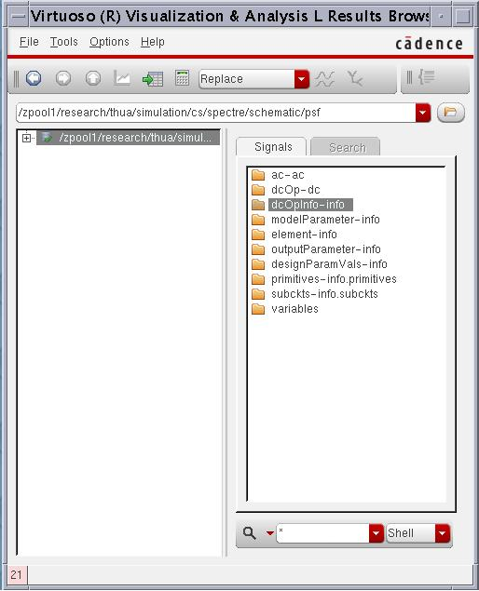

Double click on dcOpinfo-dcop (it stands for DC operating information). Then, the window shows you the signals in the right column. Notice that there is the M0, which is the name of NMOS instance in the amplifier schematic. Right click it and select table. A table pops up and its shows all DC information about the transistor. Roll down to the bottom of the table, you should make sure that your Vgs (Gate-Source DC voltage) larger that Vth (the threshold voltage) to turn on the transistor and Vds (Drain-Source DC voltage) larger than Vdsat (Drain-Source Saturation voltage) to ensure the transistor is in saturation. Locate these voltages as shown below:

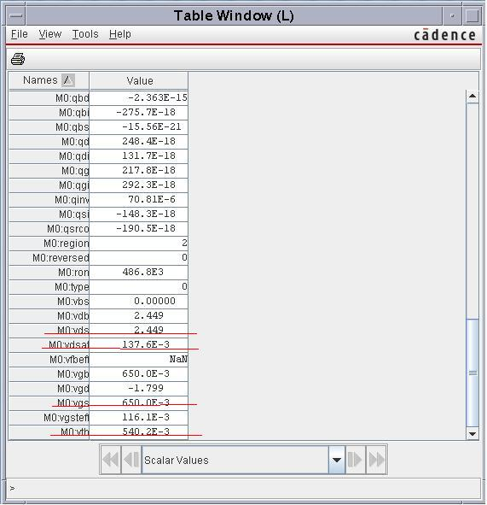

If the above mentioned constraints are not met, this means that a good DC operating point has not been achieved given the current transistor sizes. If this is the case, re-size your transistor until DC is correct. Meanwhile, check your amplifier gain from AC analysis and it should be large enough, say 15.

When DC operating point is correct and the AC voltage gain is large enough, you should be able to identify the -3dB frequency (or -3dB bandwidth) from the AC plot. Record that frequency and proceed to the next step.

3 ) compute the theoretical -3db bandwidth

For the final amplifier design you have obtained from step (2), go to again the Results Brower and invoke the table that shows all DC information of the transistor. Locate the parasitic capacitance Cgs and Cgd, the small-signal trans-conductance gm, record their values, and finally use these values to compute the theoretical -3dB bandwidth (Note that the Cgs and Cgd may be shown as negative, but you only need to use the absolute values). You might want to check the example 8.2 in the book on page 500 for that purpose. Is the theoretical frequency close to the one obtained from simulation in step (2)?

3. Interested in more amplifiers? (This part is optional)

This part is optional.

If you are interested, size the width/length ration of the following common-based and source-follower in CMOS transistors, make sure the transistors in saturation region and then simulate the circuit to identify -3dB bandwidth. Compare to the common-source amplifier.

