ECE 3235 Electronics II
Experiment # 4
Updated on 09.29, 2016.

Introduction to Cadence Tool

Note: Cadence Tool is an industry standard one for circuit analysis. It will be used in more advanced courses such as ECE4311 VLSI Design and ECE5211 Advanced Analog Integrated Circuit Design. The software will be used throughout the semester, so please spend time to get familiar with it.

1. General information

In this lab, we will use Cadence software to build the schematic for the circuit shown below, and then simulate the circuit. You might have used some other similar tools, like SPICE, HSPICE, PSPICE (OrCAD). Cadence software has the most comprehensive set of tools for circuit design and is widely used in industry and academia. Though you may only use some of the Cadence tools in this course, it is a good starting point.

The circuit shown below is a RLC circuit, which you have studied in ECE2006.

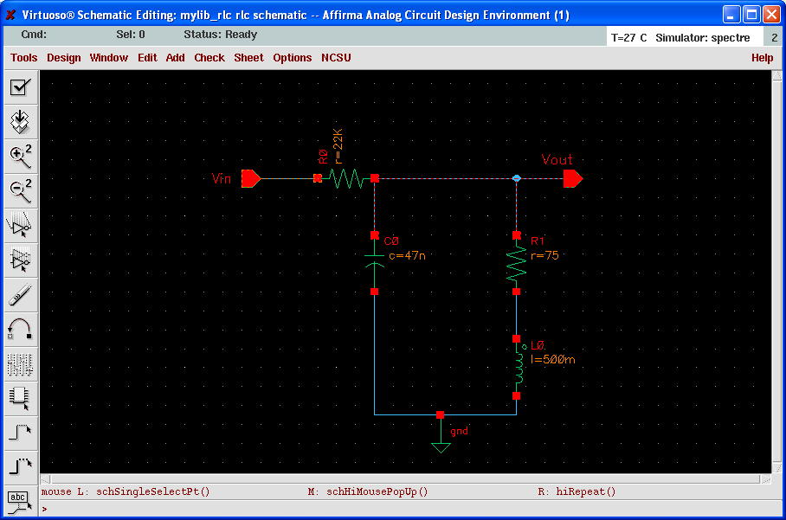

1.1 Setting up the Cadence Environment
One important thing is that Cadence software mostly runs in the UNIX/LINUX environment (operating systems). Once you login from the general student account, click on search and click Terminal to start the command window. (Note: if you are NOT familiar with UNIX OS, please do the following commands with TA’s guidance.) Then at the command prompt, type ‘xhost ̺ + ̺ cdsm’ (Note: ̺ represents one space). Then, type ‘ssh ̺ –X ̺ usename@cdsm.d.umn.edu’ and then type in the default password ‘welcome’. Then you should be on the cdsm server. Now continue to the following steps to complete the setup.
(1) create a new directory from your home directory called cadence with the following commands:

tcsh
mkdir ̺ ~/cadence

This is where you’ll organize all your Cadence files and directories. (~ in the above command and below stands for the home directory where you are when you just log in).

(2) Copy the dotfiles .* to your home directory (do not omit the . before *).

cp ̺ /zpool1/research/thua/ece3235_test/.* ̺ ~/

(3) Type the following command:

source ̺ ~/.cshrc

(4) Copy the file cds.lib to your working directory (overwrite if asked)

cp ̺ /zpool1/research/thua/ece3235_test/cds.lib ̺ ~/cadence/

(5) Create a sub-directory to the cadence directory, called Mylibs.

mkdir ̺ ~/cadence/Mylibs

(6) Create a sub-directory to the cadence directory, called Models.

mkdir ̺ ~/cadence/Models

(7) Then copy a model file to your directory Models.

cp ̺ /zpool1/research/thua/ece3235_test/Models/allModels.scs ̺ ~/cadence/Models

Note: The steps above are used to initially set up the system and need NOT be repeated from now on. So, next time when you need to start Cadence to work on your project, simply go to the Part 2 below.

2. Circuit design in Cadence
Part I Schematic Editor

2.1 log into cdsm.d.umn.edu server

Click on search and click Terminal to start the command window. Then at the command prompt, type ‘xhost ̺ + ̺ cdsm’ (Note: ̺ represents one space). Then, type ‘ssh ̺ –X ̺ usename@cdsm.d.umn.edu’ and then type in the default password ‘welcome’. Then you should be on the cdsm server.

2.2 Start Cadence

From a command prompt, type:
tcsh
source ̺ .cshrc (always do this before the next command)
cd ̺ cadence
virtuoso ̺ & (note: do not omit the & sign)

The program appears after a few moments. Do not worry about the “error” shown in the window, as long as you see “END OF USER CUSTOMIZATION”. You can then close the “What’s new” window unless you really want to know what’s new. You window would look like this:

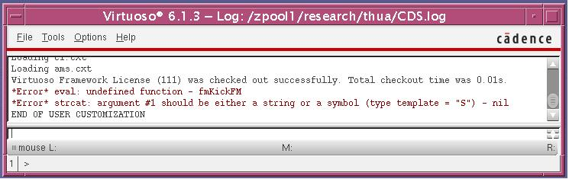

Add the library path
On the window menu, select Tools➔Library Manager, then a new window appears.
Under File, click New, then click Library…, type mylib_rlc in the name filed of the appeared window. Then select the directory to be Mylibs created before. The window should look as shown below.

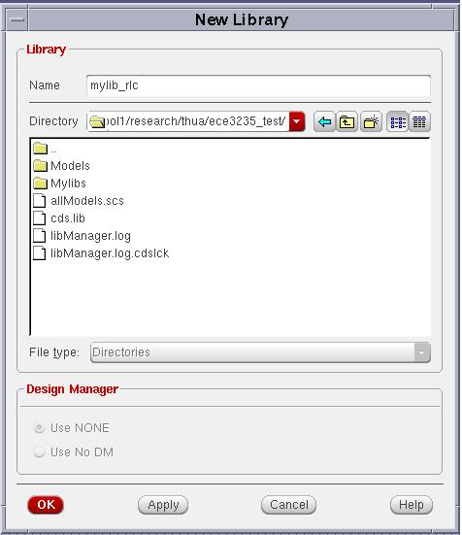

Then click ok. A new window appears and select the option “Do not need process information” as follows:

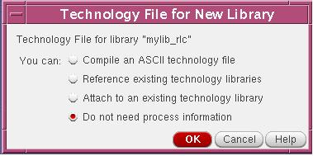

Then click ok. The steps above created a new library called mylib_rlc (check the existence in the library column of the Library Manager window).

2.3 Creating a new Design
From the Library Manager, click mylib_rlc once to highlight, select File➔ New➔Cell View, and fill in the form as shown below in order to define the new rlc schematic cell view:
- In the Cell Name field, type rlc
- In the Type selection, choose Schematic. (It should automatically define the View Name as schematic). Click OK.

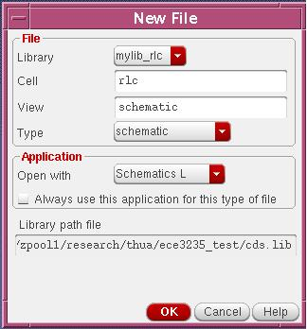
Note that a small window asking about whether you want to use a different license may appear, simply click yes. Then, an empty Schematic Editor Window with dots on the background now appears, where you will be drawing your circuit schematic as you have similarly done before in PSPICE.

2.4 Schematic Editor
The process of editing a design is called schematic capture. You can use several methods in the Cadence environment tools to achieve the same effect. We could select from the pull-down menus, or click on one of the icons, or use a shortcut letter, referred to as a Bindkey.
Browse through the icons at the top of the Composer Window, and note the “floating description” on each.

2.5 Placing the Instances
Click on the Instance Icon or select Create➔Instances… (you may also notice that the shortcut letter for this is “i”). An add instance window appear as follows.
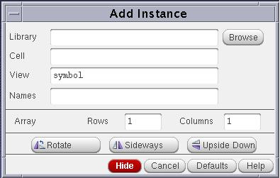
Click the Browse button in the form. The Library Brower – Add Instance window appears as shown below.
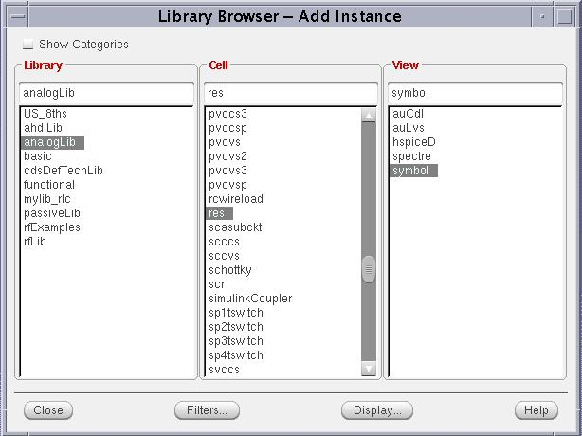
Select the following in that window as shown above:
- Under the Library column, select analogLib.
- Under the Cell column, select res (the short name for resistor)
- Under the View column, select symbol

After the selection above, the previous Add Instance window will be displayed as shown below. Before you click on the schematic window to place the resistor symbol, edit the Add Instance form by modifying the Resistance value to 22k Ohms, as shown below in the window: (as you can see, there is a lot of other parameters associated with the resistor, but leave all the rest empty for now)
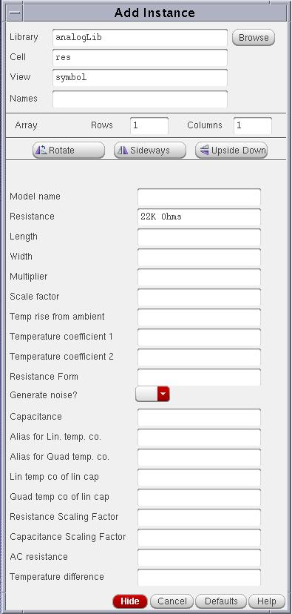
- Now click in the schematic editor window (with dots in the background) to place the resistor. (If the above Add Instance window blocks your view, you can select Hide in that window before you place the resistor).
- Another resistor symbol follows the cursor. Place it in the window then click on Cancel on the Add Instance window. The form disappears.
- Add the other instance symbols from the analogLib as indicated below,
Add an instance of capacitor from analogLib, (named cap) and set it to 47nF,
Add an instance of inductor from analogLib (named ind) and set it to 500mH
Add an instance of Ground from analogLib (named gnd).
Place the above symbols in the order as shown in the following window

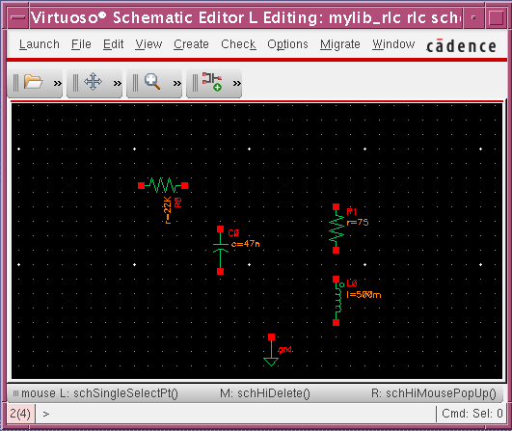

Note that the instances you placed in the schematic editor window may not be in the orientation as shown, but you can rotate them. Click on the menu Edit➔Rotate and then click on the instance you want to be rotated.

2.6 Adding the Input/Output Pins
We need to add pins to define the input and output. To add the input and output pins, Click on the menu Create➔Pin. The Add Pin form appears.
- Under Pin Names, type Vin. Note that Direction in the form reads input, as shown below.
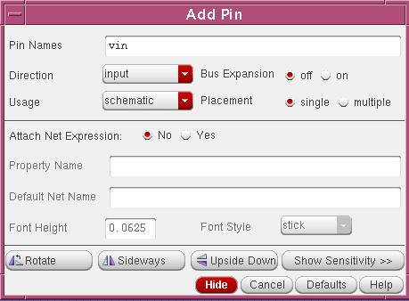
- Go back to the Schematic Editor window and click once in the window. Note that the pin named “Vin” is placed in the position you specified.
- Now, invoke the Add Pin window again. Type Vout this time, change Direction to read Output (to define the output pin). Place the Vout pin in the Schematic Editor window. Press ESC to clear the form.

After the above steps, your Schematic Window would like this:

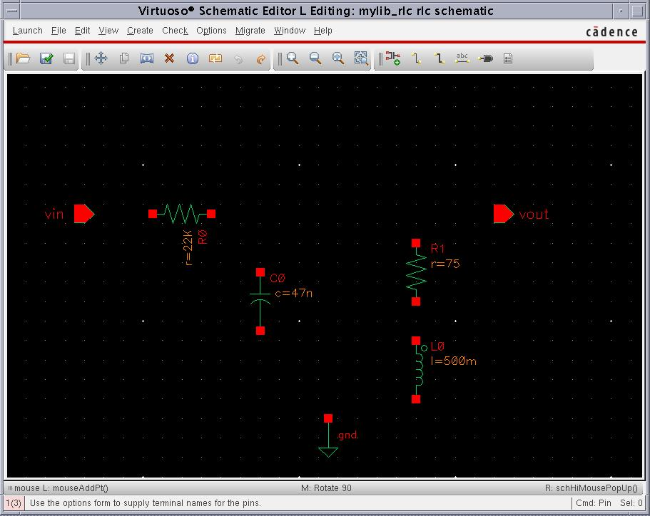

2.7 Connecting Wires
The instances in the Schematic Editor window have not been connected yet. To connect the wires, click on the icon Wire(narrow) or click Create➔wire.
- then click on one end and the other end to make wire connection
- Wire the components as shown below:

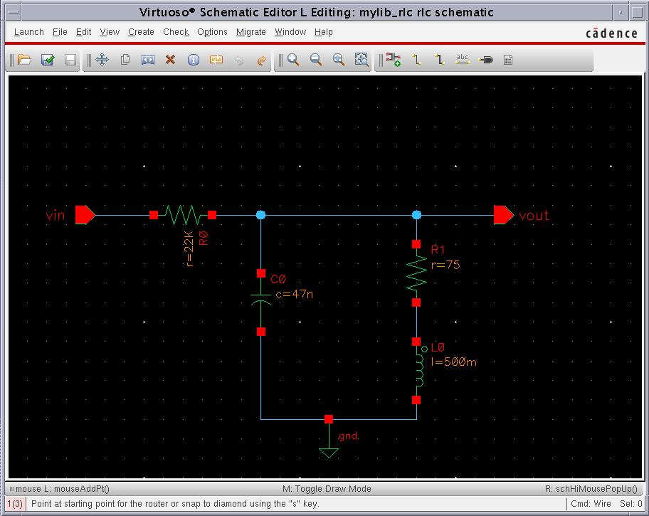

2.8 Modifying Instance Properties
To modify the properties of each instance, click once to select each individual instance, then click on the “q” key (query) on your keyboard. This is the same as selecting the instance, right-clicking using the mouse and then selecting the Properties form.
- If some of your instances in the Schematic window do not have the same values as shown in the above window, you can then change their values by doing the above step. By default, Cadence automatically writes the Instance Name.

2.9 Checking and Saving
To check and save the schematic, click on the design icon on the left, Check and Save or click on File➔Check and Save. Notice the Cadence’s Command Interpreter Window (CIW) (the window that shows a letter C when minimized) displays the following messages:

Extracting “rlc schematic"
Schematic check completed with no errors.
”mylib_rlc rlc schematic” saved.

If you get Warnings/Errors:
- Go back to your schematic and look for the “flashing” tiny squares.
- Browse back in the CIW history window and read the warning/error messages.
- Fix the warnings/errors as necessary. Warnings are not as crucial as Errors.
- For example “Dangling Wires” Warnings could be ignored.
- Click on the Check & Save icon, and repeat until the design has no errors.

2.10 Creating the Symbol Cellview
Now we’ll create a symbol (black box) to represent our circuit. The symbol view will be created based on the already-available schematic view. This is called creating a Cell view from another Cell view. (For example, go to Library Manager window, you see three columns as Library, Cell and View. We already have a view called schematic for the cell rlc, now we will create another view called symbol for the same cell rlc. In general, there are multiple views for the same cell, which act like different representations).
- From the Schematic Editor window, select Create➔Create Cellview ➔From Cellview...
This sequence creates symbols automatically, based on their primary input and output pins. The Cellview From Cellview form appears as shown below.
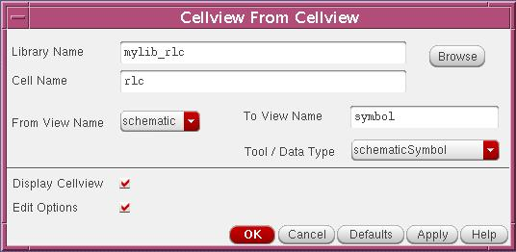
- Change “Tool/Data Type” to SchematicSymbol if this is not the default, then click OK.
- On the new form that appears, select the “Load/Save” button. The form expands.
- In the form’s lower left section, change the cyclic field next to “Load” to “Analog”.
- Click on the “Load” button to load the Analog Symbol Generation Template as follows, then click OK.

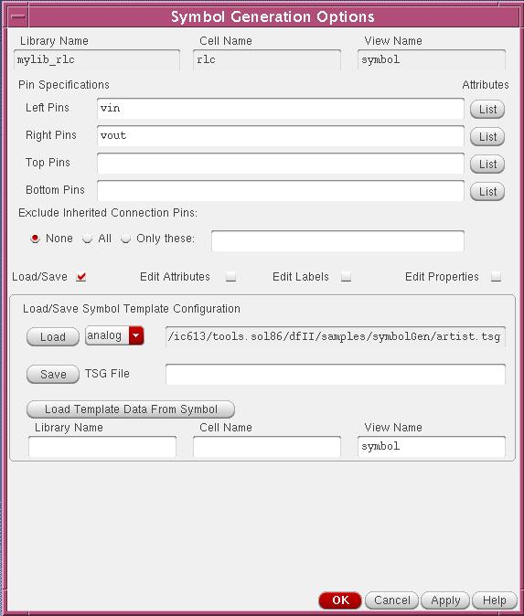

- If a message appears calling to “Overwrite Base Cell CDF”, click on No so as not to overwrite the inherited parameters in the base cell Component Description Format. A new Symbol Editor window appears
- In the Symbol Editor Window, the outside red box defines the selection region when selecting the symbol if it’s present on a schematic design. The inside green box defines the dimension of the symbol as it would show when placed in a schematic design. Expand both, and drag and drop the square pins, the cdsName, and the connecting terminals as shown in figure below:

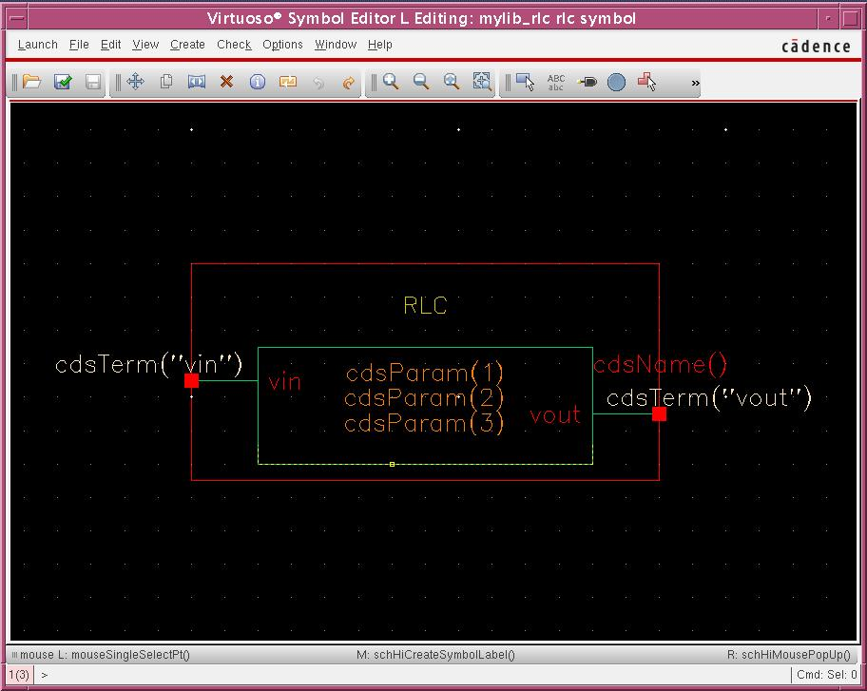
The cdsTerm(“Vout”) is a label that displays the pin names or the net names (Vout). The cdsParam(1,2,3) are labels that display parameters of an instance, e.g. 75 Ohm. The cdsName(“”) is a label that displays the instance or cell name, e.g. rlc.
- From the Symbol Editor window, Click on Create➔Label…
- An Add Symbol Label window appears, type RLC in the Label field.
- Press Enter to place the label. Click on Cancel on the form to close it. The symbol
should look as that in the window above with “RLC” symbol.
- Now press the Save icon in your design window. The CIW should display the message: "rlc symbol" saved.
- From the pull-down menus of the Symbol Editor window, select Window ➔ Close.
- The Schematic Editor window should be still open. Close it using Window➔ Close.

The produced symbol will be used in the cell test_rlc to be created next. This is a circuit model that’s used to test the performance of a design. It will incorporate input signal sources, power, ground, the circuit load (e.g a capacitance), and the positive and negative supply rails (buses).

2.11 Creating the test circuit (test_rlc)
We’ll now create a new cell using the rlc symbol created before as one of its instances.
- From the Library Manager Window (open it if you do not have it open), highlight mylib_rlc in the Library column, go to: File➔ New➔ Cell view...
- Create a new Cell called test_rlc, select Schematic in the type field if it is not
- Click OK. A new Schematic Editor window appears.
- Connect your new circuit using components according the schematic figure shown below.
- To add RLC to the editor, select Create➔Instance…. In the appeared Add instance window, browse library to mylib_rlc and select rlc in cell column and then symbol in View column. Then place it in the Schematic Editor window. Click Cancel to close the Add instance window.
- To add the voltage source, again select Create➔Instance…. In the appeared Add instance window, browse library to analogLib, select vsin in the Cell column and then symbol in the View column. Notice that a property window appears for the voltage source (vsin here stands for a sinusoidal voltage source).

!!IMPORTANT!!
Input 0 for the DC voltage field, 1 for AC magnitude field, 50m in Amplitude field, 1M in frequency field and leave all others unchanged. Please note that the units of measure like V, Hz will follow automatically in the fields.

- Repeat the above steps to add a capacitor and a ground as shown in the window below.
- After all instanced are placed, connect them with wires to complete the circuit. Please go back to previous pages for how to connect wires if needed.
- After you make the wire connections, click on the wire connected to the vsin so that it is highlighted, then right click, select Add name. An add wire name window appears, type Vin in the names field, then go to Schematic Editor window and place the name on that wire. In this way, that wire will have a name, which is easy to control later. Similarly, give the name Vout for the output wire connected to the load capacitor.
-. Finally, the test schematic should look like below:
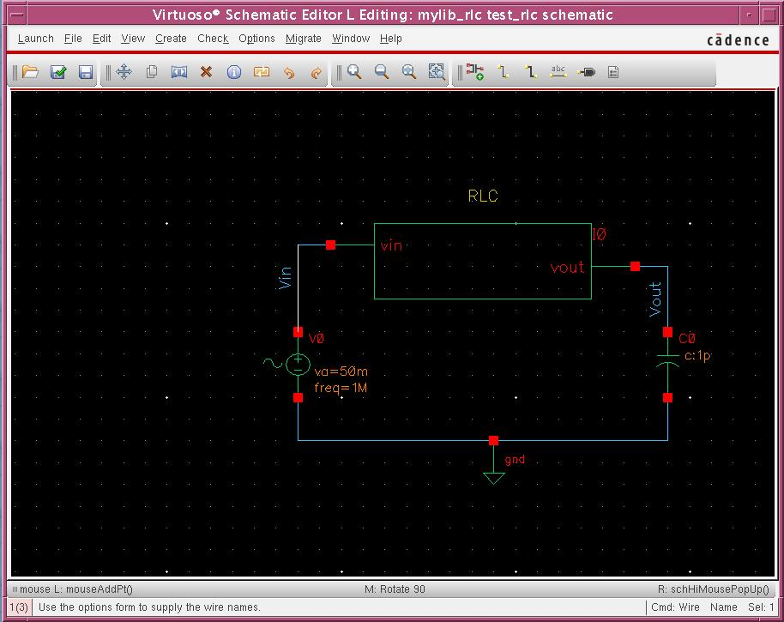

- Click on the Check and Save icon or File➔check and save when done.

Part II Simulation in ADE (Analog Design Environment)

2.12 Initializing the Simulation Environment
In part I, we have built the circuit schematic. The next step is to simulate the circuit, so that designers can verify the functionality of the circuit (which is typically the design process). Before starting the simulation, make sure that your test_rlc schematic is open.
- In the test_rlc Schematic Editor window, select Launch➔ADE L. In a few moments, the Vituoso Analog Design Environment window appears, as shown below.
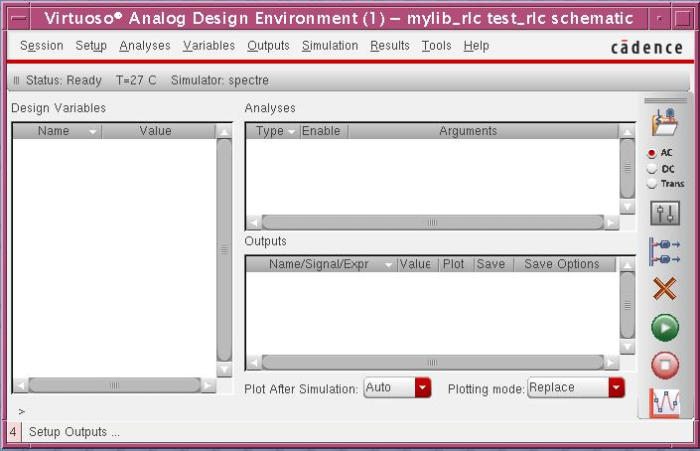
Again, here it may ask for the license, just click on yes. Also, another window titled What’s New in Analog/Mixed Signal appears. Close it to avoid too many windows unless you really want to read it.
The icons on the right provide quick access to frequent commands/menus. The title of the window lists Library, Cell, and Cell View of the design being simulated (it is mylib_rlc test_rlc schematic in this case). The Analyses Area: Lists the types of analyses, any arguments (i.e. time interval), and weather it’s enabled to perform the simulation in the current run (it is empty now because we have not specified any run yet). The Design Variables Area: Lists components set as variables, i.e., a Capacitor, C1, varying from 1uF to 1pF (empty now as well). The Outputs Area: Lists names of nets/signals/expressions/ports to be plotted on the output waveform window (also empty now).
The following sections will provide more detailed descriptions on how to run simulation.

2.13a. Choosing a Simulation Engine
- We’ll select the simulation engine to be Spectre. In the window, select Setup➔Simulator/Directory/Host
- In the appeared window as follows, ensure the Simulator cyclic field is reading Spectre
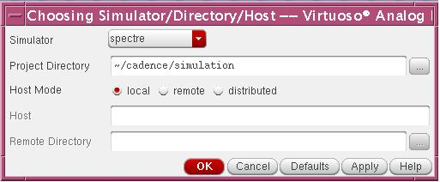

- Change the Project Directory to read ~/cadence/simulation. This creates a new directory under your cadence folder.
-. Click ok. If you’re prompted to “save the current state”. Click Yes, and confirm the name as state1 in the form that opens afterwards. Click OK. If not, just proceed.

2.13b. Plugging in models
- In the Analog Design Environment window, select Setup ➔Model library. In the appeared window as follows, click on Browse button on the right hand side, go to the directory Models and select the file allModels.scs, click on open and then notice that the model file is added in the window.

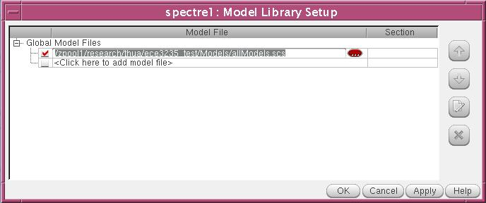

Click on ok to dismiss the window.

2.14 Choosing the Analyses
- In the Analog Design Environment window, click the Choose Analysis icon. Instead, you could select it from Analysis ➔ Choose pull down menu. The Choosing Analysis form appears as follows:

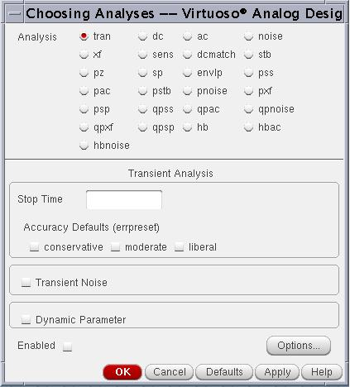

We’ll simultaneously set up several analyses modes in this window.
• Transient analysis: This provides the transient output response of the circuit with respect to time. The user specifies the time period and the time variant input waveform while the simulator calculates the output response.
• AC analysis: This simulates the AC performance of the circuit as a function of frequency, and is based upon the small-signal frequency response model.
• DC Operating Point: This analysis simply determines the D.C. operating point of the circuit based on the parameters present on the schematic assuming all capacitors opened and all inductors shorted. It is the default mode and is automatically performed before any other analysis in order to determine the initial state of the circuit.
• DC sweep mode: This generates DC transfer characteristics for the circuit by varying a user specified independent source over a range of values.

2.15 Transient Analysis
1. In the Analysis Section, select tran.
2. Set the Stop Time field to 3u.
3. Turn on the Enabled field (at the lower left corner of the window).
4. Click APPLY. (do not click OK yet as we need to set up more analyses)
Notice that in the Analog Design Environment window, under the Analysis Section, a line was listed to describe this analysis.

2.16 AC Analysis
1. In the Analysis Section, select ac. The form expands as follows:

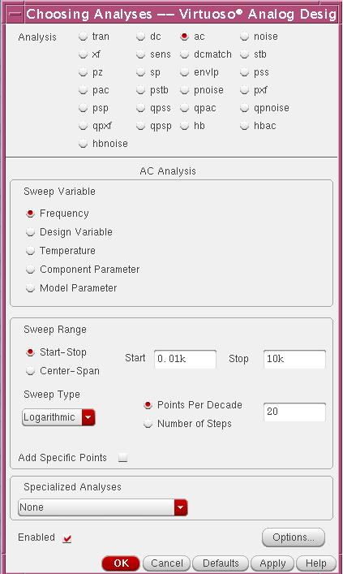

2. Set the Sweep Variable to Frequency(note the other sweep variables).
3. Set the Sweep Range to Start-Stop. (Start: 0.01k, Stop: 10k). The units of measure is automatically Hz so you do not have to put in Hz.
4. Set the Sweep Type to Logarithmic, with 20 Points Per Decade.
5. Turn on the Enabled field.
6. Click on Apply.
Notice in the Analog Design Environment window, under the Analysis Section, a line was added to describe this analysis.

2.17 DC Sweep and DC Operating Point
1. In the Analysis Section, select dc. Note that the form changes accordingly.
2. In the Sweep Variable section, select Component Parameter. Note the form changes accordingly.
3. Click on Select Component. This allows for selecting the instance on the schematic.
4. Click on the supply source from the Schematic window.
5. A form appears listing all the instances parameters. Select the dc parameter in the first line. Then click OK to close the form.
6. In the Sweep Range section, select Start-Stop. (Start: 0, Stop:100)
7. Turn on the Enabled field.
8. Click OK this time. When done, the form should appear as shown next.

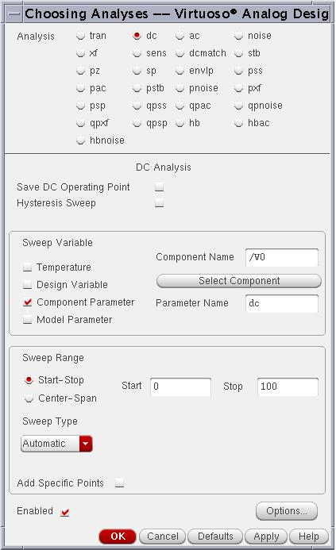
Notice in the Analog Design Environment window, under the Analysis Section, a line was added to describe this analysis. The final look of the Analog Design Environment window should be as shown below.

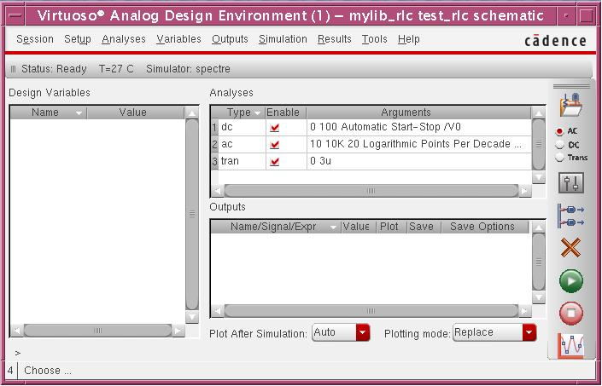

2.18 Saving and Plotting Simulation Data
The simulation environment is configured to save all node voltages in the design by default. You can modify the default to save all terminal currents also, or you can select specific set of nodes to save. We’ll select these nodes from the schematic window.
- Select Output ➔ To be Plotted ➔ Select on Schematic. Note the circuit Schematic window will jump in front of you for your selection. Node voltages can be selected by clicking on the wire in the schematic window, and currents by clicking on the terminals. Unselecting can be performed either by clicking on the terminal/node again, or by selecting the corresponding line in the Outputs section of the Analog Design Environment window and clicking on the Delete icon. In this lab, select the input and output wires of the test_rlc circuit. Observe the simulation window as the wires get added as follows:

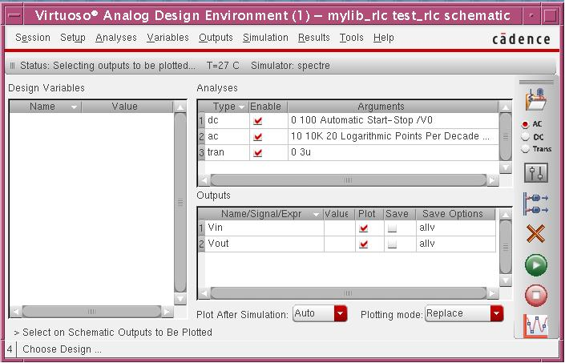

2.19 Running the Simulation - The Waveform Window
- Click on the Netlist and Run icon on the right (the Green button). Alternatively, select Simulation ➔ Netlist and Run.
- When it complete, the plots are shown automatically in a window. The 3 Analysis Responses are shown in separate sub-windows as follows.

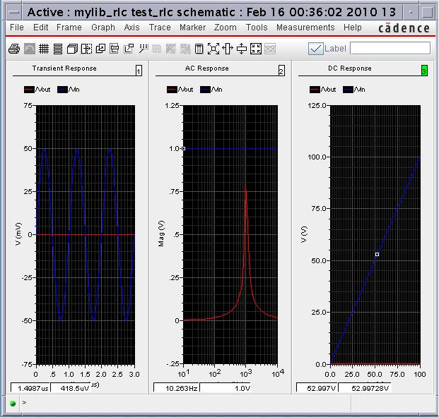

Notice that another window also appears, which shows you the status of the simulation. You can simply close that window. The DC response is not clear due to the voltage divider effect.

We’ll next modify the appearance of the displayed waveforms.
- Click anywhere in the DC Response area to work in this section. Notice the highlighted box reading “3” at the top-right corner of the section.
- Select Axes ➔ Strips, or click on the Switch Axis Mode icon on the left. Observe the 2 separate plots displayed. Repeat for the 2 other plots (1, 2).

The windows then changes as follows:

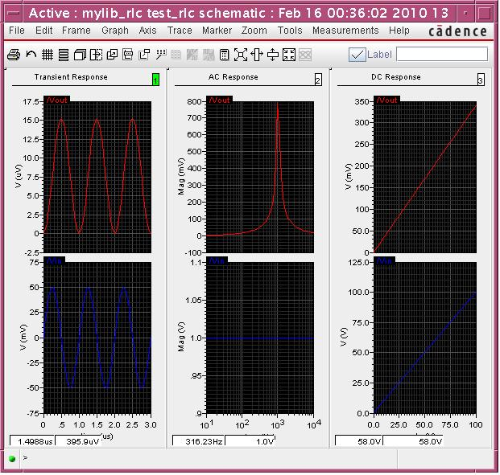

- Now we use the markers to measure the output peak-to-peak amplitude of the Transient Response signal. Click on the Marker➔Place➔Trace Marker, then place the marker on the positive peak of the output waveform. Then select Marker➔Add Delta, and place the marker at the negative peak. Notice the data appears in the window, which shows the time difference and voltage difference between two points we selected.
- Select the AC Response section. Add a Trace Marker as we did above. Pull the marker up, till it can’t go up any further. Read the resonance frequency from the data at the bottom of the window.

!!IMPORTANT!!

Now, please spend some time to look into the simulation results. Do the results make sense to you?

Note that for Transient Response, the two plots in that column shows the circuit input (labeled as /Vin in the plot) and output (labeled as /Vout) changes as a function of frequency. Verify the input sinusoidal input waveform, is this what you specify for the voltage source vsin in the test_rlc circuit schematic? Measure the frequency of the input sin waveform, is the frequency what you specify for the voltage source vsin? The output waveform resembles a sinusoidal waveform as well, but the amplitude is so small compared to the input, why?

Now go to the AC response column. Again, two plots are shown there. The upper plot shows what the output is as a function of frequency (please clearly notice the x-axis is frequency as this is AC analysis). The lower plot shows what the input is as a function of frequency. Notice it is horizontal line. Why this is so? Is the magnitude 1.0V what you specified for the voltage source vsin in the teset_rlc circuit schematic? Why don’t we specify smaller magnitude such as 1mV, because AC analysis is small-signal analysis and the signal magnitude is suppose to be “small”? You can change it to 1mV and run the simulation again. What is the difference? So, does it really matter between 1mV and 1V?

Finally, please go to the DC response column. The upper plots show what the output DC voltage is as a function of input DC voltage. Notice the x-axis is the DC voltage we swept, as we did set up to sweep the DC voltage in DC analysis previously. For example, when input DC voltage is 100V, the output DC voltage is shown as about 340mV, is this correct? The lower plot shows what the input DC voltage is as a function of input DC voltage. So, of course, that would be a straight line. If you want to delete the bottom Vin-Vin plot (as we are typically interested in the Vout-Vin plot) in the DC Response Column, click on the bottom waveform, and press the Del key on your keyboard.

2.20 saving the analyses setting and simulation results

Now, before you close the Analog Design Environment window, you may want to save the analyses setting and simulation results first, as next time you will not need to do it again. Click Session➔Save State and a window appears as follows:

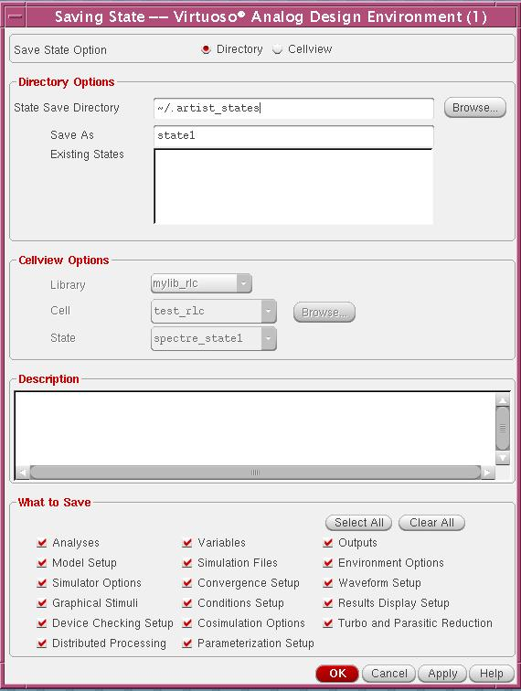

A default state name called state1 is given, but you can change it to a different name if you want. Then, you can click ok. Next time, if you want to simulate the circuit again, you only need to click Session➔Load State to re-load the analyses setting and simulation results. As you probably have noticed, we can save multiple states for the same circuit.

Part III What to submit up to now?

1) A print of the circuit schematic of rlc?
2) A print of the circuit schematic of test_rlc?
3) The output waveform from simulation?

Part IV Building up an OpAmp model

In this part, you have the chance to build up an Operational Amplifier model using resistor, capacitor, diodes, VCVS (voltage controlled voltage source) etc. The model your are going to build is called a behavior model or a macromodel for the real OpAmp. The models include many of the non-idealities of real OpAmp, but does not include all of non-idealities. You will be using this close-to-ideal OpAmp in the rest of the course to simulation OpAmp based various amplifier circuits.
1) Build up the OpAmp model as shown in the next page (attached online). Select all the components from analogLib. Make a print of it.
2) Build up the inverting amplifier as shown in the next page (attached online). First, you have to create a symbol for the OpAmp model you make in 1) and then plug in here in the test circuit. Make a print of it.
3) Do an AC frequency analysis for the inverting amplifier and make a print of the output waveform.

