**The Gothic Genre**

**A.** celebrate a vanishing, ghostly world of obsolete but admirable values set against a modern, if perhaps more mundane or “disenchanted,” world

**B.** describe a tenacious enclave of backward, de-evolved, degraded, or corrupt values, as opposed to the modern world

**C.** portray irrational, supernatural, or otherworldly events set against a rational, natural, or everyday background.

**D.** present a pathologically abnormal or deviant character coming into Gothic-style contact with the present-day, conventional world

**A.** a divided or pathological mind of a character

**B.** a dis-integrated or pathological family

**C.** a dis-integrated or obsolete culture or social order

**A.** Settings are typically divided up into lots of hidden spaces by trap doors, sliding panels, revolving bookcases--or twisted into maze-like and labyrinthine confusion.

**B.** Many Gothic settings are also dis-integrated from the world (society, history, "reality")

**C.** Dis-integrated settings and spaces lend the effect of mysteriousness, confinement, and isolation

**D.** Common Gothic settings include isolating places such as a house, ship, village, forest, etc.

**A**. a rejection of, challenge to, or criticism of present-day, common-sense norms (**critical function**), ***OR***

**B**. a call for vigilance and continued "normalization" of status quo (**conservative function**).

Sometimes these two functions can operate in the same text.

**A.** a split personality that is divided against/from itself

**B.** pairs of characters who are really two sides of one healthy person and who are each incomplete—and thus pathological--without one another.

**A.** an inability to grow, change or adapt

**B.** guilt over, or repression of, events in the past

**C** . a dis-integration or disassociation from

1. from a “natural” or conventional self

2. from present-day society (sometimes

termed, “decadence”)

3. from history

4. from "reality" (as socially defined)

**D.** withdrawal and isolation, which leads to an effect of secrecy and mystery. (The effect of an unseen or unseeable pathology is ***terror***; the effect of a pathology that's graphically revealed is ***horror***.)

WRIT 1506 | Stroupe

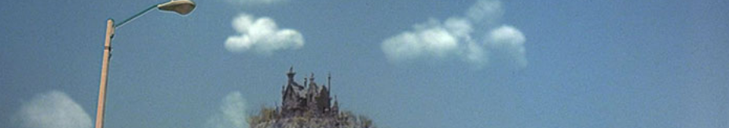

|  |  |  |
| --- | --- | --- |
| **1. PATHOLOGY**  At the center of all Gothic or Gothic inflected narratives is a **pathology** (physical, mental, moral, social, spiritual disorder). This pathology can result in/from:  **2. DOUBLING**  In the Gothic genre, this pathological dis-integration is embodied in **split or doubled characters**. | **3. DIS-INTEGRATED SETTINGS**  Like characters, Gothic **settings** can also be dis-integrated like the characters.  **4. ATHROPOMORPHISM**  In the Gothic genre, settings and objects are **anthropomorphized** (attributing human motivations and characteristics to inanimate objects, places, etc.) and constructed as symbols for... | **5. SOCIAL COMMENTARY**  Many Gothic narratives set events against a background of the modern, mundane, or otherwise "common sense" world, which enables the writer not only to tell a Gothic tale but to **suggest** a **commentary on social, historical, or psychological developments**. For instance, a writer might…  **6. CRITICAL OR CONSERVATIVE FUNCTION**  Gothic pathology necessarily suggests a **contradiction of common-sense assurances**, and may either represent |
|  |  |  |