Passion

Genius

Intuition

**KEY WORDS**

Nature

Imagination

Sublime

**Romanticism**

WRIT 1506 | Stroupe

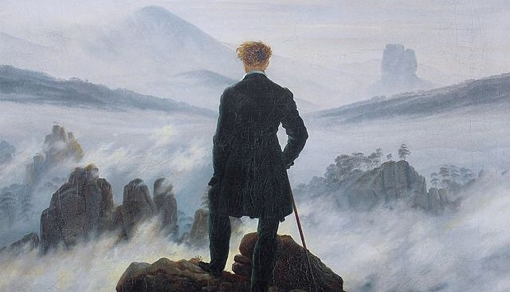

|  |  |  |
| --- | --- | --- |
| **HISTORY**  Emergent: 1780s  Dominant: 1790s – 1850s  Residual: 1850s – present  **CHARACTERISTICS**  1. identity construed as an **individual, subjective, emotional self,**  2. value placed on the meaning of peak experiences of fusion, synthesis, and the **sublime**  3. attention to **nature and** **rural landscapes** as source of inspiration and consolation  4. new interest in **common people and places as subjects of writing;** use ofeveryday language, folk tales; attention to humble and natural modes of life  5. **sympathy with marginalized and oppressed groups and with revolutionary movements**, emphasizing the unity of mankind.  [Note that these characteristics can be expressed in idealist, ironic, satirical, or Gothic ways.] | **HISTORICAL CAUSES AND CONDITIONS**  **A.** rise of **democratic, political practices** placing more authority on the individual, and less on social institutions and economic-class influences.  **B.** entering the “**individualist” phase of capitalist** development emphasizes the “rights and powers of individuals” in local and regional contexts such as towns, villages, and counties (Terry Eagleton qtd. in Cobley 88).  **C.** in literature, a **reaction against neoclassical styles** and models, which were seen as over-dependent on conventional forms and limited by thematic and stylistic restraints.  **D.** development of a **popular marketplace for literary authorship** due to technological advances in printing, paper making, transportation, as well as increased literacy and | **QUOTATIONS**  “To believe your own thought, to believe that what is true for you in your private heart is true for all men, — that is genius. Speak your latent conviction, and it shall be the universal sense; for the inmost in due time becomes the outmost,—and our first thought is rendered back to us by the trumpets of the Last Judgment.”  – Ralph Waldo Emerson, “Self Reliance”(1841)  “It is impossible to read the compositions of the most celebrated writers of the present day without being startled with the electric life which burns within their words. They measure the circumference and sound the depths of human nature with a comprehensive and all-penetrating spirit, and they are themselves perhaps the most sincerely astonished at its manifestations; for it is less their spirit than the spirit of the age…. Poets are the unacknowledged legislators of the world. “  - Percy Bysshe Shelley, “A Defense of  Poetry” (1821).  Nature is  "[t]he anchor of my purest thoughts, the nurse,  The guide, the guardian of my heart, and soul  Of all my moral being."  – William Wordsworth, "Tintern Abbey" ll  (1789) |
|  |  |  |