German Expressionism/Modernism

(Tom Wait’s “Hell Broke Luce”)

WRIT 1506/Stroupe

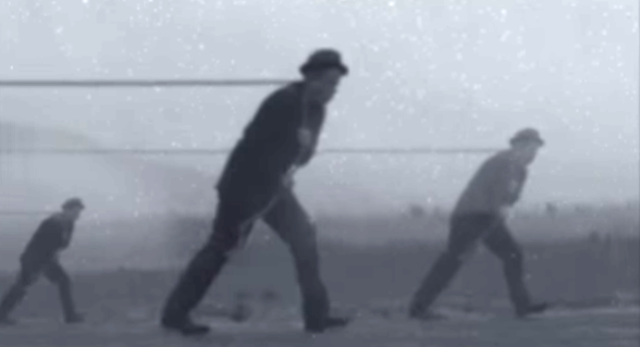

Belief in the **nuance of psychological experience and the multiplicity or “fragmentation” of self** (Cobley 113)—in contrast to the possibility of a stable, unified, rationalistic viewpoint or identity posed by previous -isms.

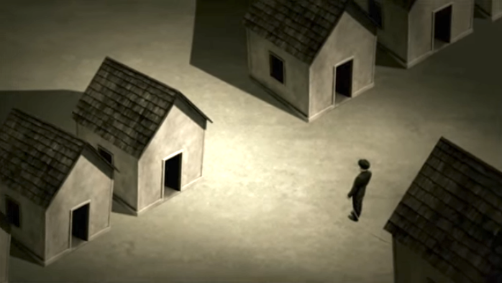

**Mistrust or inaccessibility of the past** as a guide for solving contemporary problems or representing modern experience.

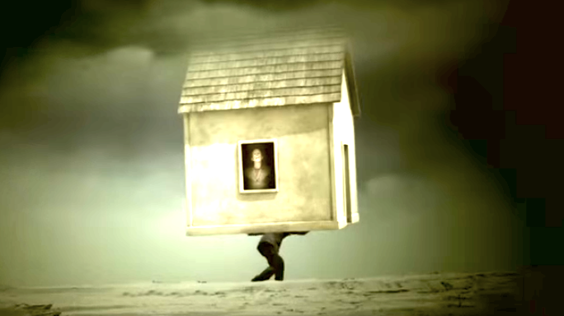

Skepticism toward **mass culture and social institutions**, which are contrasted to the authenticity of a reflexive self which is “closed, autonomous, antagonistic” and often alienated (Cobley 135)

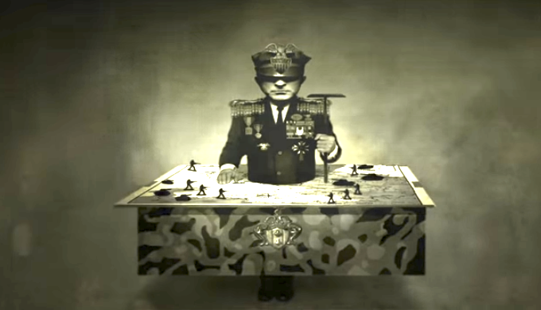

Distrust of **official truths or communal, common-sense assumptions.**

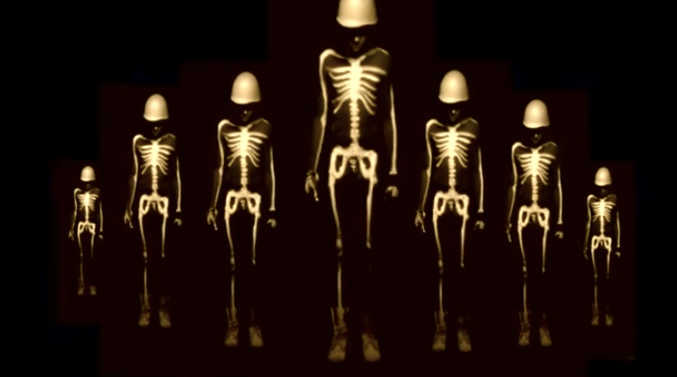

Recognition of the primary role of the **unconscious** in identify and the experience of life (Freudian repression, for example): “the human ego is not even master of its own house” (Cobley 137)