Abstract
Introduction The problem posed is to use a model to find the best design for a traffic circle. We developed a simulator to model the performance of traffic circles under varying traffic densities. This simulator allows for a variable number of lanes and a variable number of entrances and exits. We considered two ways of controlling traffic in the circle: stop signs at each incoming road and yield signs at each incoming road.
Model Our simulator created traffic circles which are divided into cells. The traffic flow for one whole day is modeled. Cars arrive at entrance queues at a rate that varies throughout the day. At each iteration, cars enter the circle and move from cell to cell according to some basic rules: cars accelerate to the maximum speed if possible, and they always avoid collisions. In multiple-lane circles, cars can change lanes in order to go faster. The performance of each traffic circle is measured by the average time it takes to get through the circle.
Strengths and Weaknesses The biggest drawback of our approach is that we make many unrealistic assumptions about car behavior. The advantage of our approach is that we include some of the complexities of car behavior.
Table of Contents

I. Introduction 3

II. Construction of a Traffic Circle 4

III. Poisson Probability Distribution 6

IV. Simulation 7

V. Simulation Algorithm 9

VI. Results and Technical Summary 13

VII. Comments 14

Appendix A: Result Graphs 15

Appendix B: Program Code 18

Appendix C: Results Tables 39
I. Introduction
The problem posed is to use a model to find the best design for a traffic circle in a variety of different circumstances. We developed a simulation using Java and Groovy programming languages to model the performance of traffic circles under varying traffic densities over the course of a full day, iterating each second. This simulator allows for various different types of traffic circles. We considered two ways of controlling traffic in the circle: stop signs at each incoming road and yield signs at each incoming road, as well as variations on the numbers of lanes, intersections, incoming lanes per intersection. These variables were also related to how heavy the traffic load coming in was, which was modeled after a 9-5 workday via a Poisson probability distribution, which generated new cars. The performance of the traffic is measured by the average time that it takes a car to get through the circle, from the time it arrives in the entrance queue to the time it exits the circle, as well as the time spent waiting in the queues.

II. Construction of a Traffic Circle
Our model is a discrete time model using cells to represent areas of each lane around the circle. We started our model with a fixed number of cells in each lane and the assumption that a car could occupy one cell at a time. We also assumed that the only possible speeds of any car were 0, 1, or 2 cells per second. After some initial testing, we found it was more realistic to split the circles into twice as many cells and allow the cars to occupy two cells at once and travel from 0 to 4 half-cells per second. Compare this to increasing the resolution of an image.
We looked at several reports on the suggested dimensions of roundabouts in the U.S. to determine the dimensions that would most accurately model true life. Our final construction conformed closest to that described by the United Stated Department of Transportation’s “Roundabouts: An Informational Guide.” Regardless of the number of lanes, the width of each lane and, thereby, cell, around the circle is estimated at 15 feet. For a single-lane circle, the diameter of the inner circle is 30 feet and for any multiple-lane circle, the diameter of the inner circle is 60 feet. These diameters allow for cars in multiple-lane circles more easily travel faster through the circle. A summary of the dimensions can be seen in the following table.
Table 1
Single or Multiple | Number of Lanes | Inside Diameter of Inner Circle | Outside Diameter of Outermost Circle | Half-Cells in Outermost Circle
Single | 1 | 30 feet | 60 feet | 24
Multiple | 2 | 60 feet | 90 feet | 40
Multiple | 3 | 60 feet | 120 feet | 48
Multiple | 4 | 60 feet | 150 feet | 56
Multiple | 5 | 60 feet | 180 feet | 64
Multiple | 6 | 60 feet | 210 feet | 72

In the research we found, the length of the cells was approximately 7.5 meters or 24.375 feet. To simplify calculations, we adjusted the length of each full cell, that is the inner circumference, to 15*π/2 feet which is approximately 7.25 meters or 23.56 feet. Then we easily split the cells into two half-cells with inner circumferences of 15*π/4. Because of the diameters, a single-lane circle is split into 24 half-cells. The inner lane of a multiple-lane circle is split into 32 half-cells and each subsequent lane moving out of the circle has 8 more half-cells. Although the outer circumference of a cell depends on the distance of the lane from the center of the circle, the inner circumference of each cell is always the same. For example, a 3 lane circle has 32 half-cells in the inside lane, 40 half-cells in middle lane, and 48 half-cells in the outside lane
The model is discrete with one iteration every second. The possible speeds of each car being 0, 1, 2, 3, or 4 half-cells per second translate to speeds which can be seen in the following table, Table 2.
Table 2: Translation Between Simulation Speed and Real Speed
Half-Cells per Second | 0 | 1 | 2 | 3 | 4
Miles per Hour | 0 | 8.0325 | 16.065 | 24.0975 | 32.13

The suggested maximum speeds in a modern traffic circle are suggested to be between 25 and 35 mph, so these increments are very realistic.
III. Poisson Traffic Density Distribution
At each iteration, cars arrive in entrance queues according to a Poisson distribution. The Poisson distribution is commonly used to model traffic flows. Arrivals are randomly distributed among the entrances of the circle. The arrival rate varies from hour to hour, with peaks at 8am and 4pm. The maximum arrival rate for a single-lane traffic circle is 1,800 cars per hour. According to the Federal Highway Administration’s Roundabouts: An information Guide, 1,800 cars per hour is the maximum traffic density that a single-lane traffic circle should be expected to handle. For multiple-lane traffic circles, the arrival rate at each time is equal to the arrival rate for a single-lane circle times the number of lanes in the circle.
IV. Simulation
The program first creates a traffic circle that is divided into cells according to the relevant options. Then, incoming traffic is generated and car actions are simulated according to a driving algorithm we have assumed. The simulation program is run, iterating at each second, for a 24-hour period and results are output.
Entering the Queue
Each entrance/intersection to the circle contains a queue. Cars arrive in the queue according to a Poisson distribution modeled after the workday. If the entrance has a stop sign, each car must remain in the queue for one iteration before being eligible to enter the circle.
Entering the Circle
If a queue has car(s) that are eligible to enter the circle, the first car in the queue determines whether or not the entrance cell corresponding to that queue will be occupied in the next iteration. If the entrance cell is open, the car enters the circle and sets its speed to 1. If there is an additional incoming lane per intersection and the second outer lane is also empty, a similar car that is determined to be in the left lane (according to the algorithm) is placed in the second outer lane, beginning its TrafficCircle activity.
Moving in the Circle
Our algorithm for the movement of cars in the circle is based on the Nagel-Schreckenberg (NaSch) model, which is described by Schadchneider. At the beginning of each iteration of the NaSch model, cars set their velocity, denoted as v, to be the minimum of one plus their velocity in the previous period and the maximum speed. (The velocity represents the number of cells that the car will cover in one time period). The car then adjusts its speed to be the minimum of v and the number of empty cells that the car has in front of it. If there is another car within v units, there is a certain probability that the car will over-brake, decreasing its speed even further than necessary.
We modified the NaSch model by allowing cars to move into or past a cell that has been occupied in the previous iteration and by eliminating the random over-braking. If a car is directly behind another car, it sets its next speed to one + the number of vacant cells in front of it in its lane for the next iteration (speed is now calculated at the end of an iteration). If this plan would lead to a collision, the car without the right-of-way lowers to speed to avoid the collision.
Changing Lanes
Inside lanes in order to speed up and then move back to the outside as its exit approaches. Its decision on whether or not to change lanes depends on the lane that it is in, the total number of entrances and exits in the circle, its distance from its exit, and the number of times that it has missed its exit. If a car wishes to change lanes, it will check for cars in the merge lane before attempting the merge.
Exiting the Circle
At the beginning of each one-second iteration, any car in the outer-most lane that will exceed its destination intersection’s exit cell will leave and its statistics will be logged.
V. Traffic Simulation Algorithm

To analyze the efficiency of our algorithm, we had to make many assumptions about the way humans drive cars. We assumed a driving system and coded it into a program written in the Groovy programming language. To evaluate our current options for a traffic circle, we simulated an entire day, with actions by each entity at each of the 84000 seconds in a day. Following is the operation algorithm that was completed in each second of the 86400-second day for a TrafficCircle with the given options. An intersection, in this context, is a road coming into the circle. Italics denote comments.

TrafficCircle Options
Number of Intersections
Number of Lanes
Number of Cars starting in each intersection
Incoming Lane Type (Stop or Yield)
Number of Cells in the inner-most lane
Number of Incoming Lanes in each intersection (for all intersections)

Begin 1-Second Iteration

Pre-Operation Tasks
For each intersection
Generate a number of cars added to the queue based on the relevant Poisson probability distribution (which uses a traffic heaviness index based on the number of intersections to determine probabilities)
Add the generated number of car(s) to the queue for the intersection.
Cars are generated with random destinations based evenly on the number of other intersections, with a 1 in ((Number of Intersections)*5) probability of entering the circle by accident and needing to come back.

For each car in the driving circle
increment the total number of seconds that car has been in the circle.

Go To: Traffic Circle Algorithm Category (one category implemented)

Incoming Traffic Yields/Stops to Active (In-Circle) Cars

Phase 1: Cars determine their desired next position based on their latest speed and positions

Distance to a cell or exit refers to the distance from a car’s current cell, translated to the outermost lane, to its destination cell. Ex. 0.5 = 50%, halfway around the circle

For each Car: (henceforth named car)
Determine if car will exit
If car is in lane 0
If car will succeed its destination’s exit cell with its current speed, the car will exit. Log car’s statistics and add it to the done queue
If car will not exit
Determine if car wishes to change lanes
If car is further from its exit than in the previous iteration
Increment car’s missed lanes
If car is in lane 0
If translated car distance to exit cell is less than (1/NumberOfIntersections) or if car has missed an exit
Set car to no lane change desired
Else
Set car to merge inward desired
Else
If car has not missed an exit
If car is less than (0.5 + (0.5 * car lane))/NumberOfIntersections distance away from its exit cell
Plan for merge in
Else If distance is less than 0.5 from exit cell
Do not plan for merge
Else
Plan for merge out
Else If car has missed one exit
If distance from exit cell is less than 0.75
Plan for merge In
Else
Do not plan for merge
Else
Plan for merge in

Determine if car should attempt to change lanes
If another car is in the cell next to car’s middle in the merge lane
Cancel merge plan
If another car is in the cell next to car’s front in the merge lane and the incumbent is travelling at a slower speed
Cancel merge plan
If another car is in the cell next to car’s back in the merge lane and the incumbent is travelling at a greater speed
Cancel merge plan

Lane change pre-check is complete. Configure final desired next positions.
Set car’s desired next position and lane based on current cell, current speed, and lane change

(END PHASE 1, MAJOR CAR LOOP)

Phase 2: Assess and correct errors (possible collisions) in the desired next positions

At every point (angle relative to the top of the circle), check cells in all lanes from outside to inside and then to outside lane again, against the flow of traffic. This will create a sweeping motion like the minute hand from 12:00 to 1:00. Cells are checked from outside to inside and then inside to outside at each outer cell (comparable to a minute) because fixing certain errors can introduce errors of another kind.

For each cell in the outermost lane, counting backwards from the last cell
For each cell in all lanes that is even with the outer lane cell, outside to inside and then inside to outside
For each in-circle car
If next position of car is in this lane and translated cell, add car to list of occupants
If there are more than 1 occupants
Account for the “letting someone in” phenomenon
If there are exactly 2 occupants and (one occupant started in the lane and the other is merging) and the non-merging occupant can sacrifice the cells without stopping
On a probability of (10% / (non-merging occupant’s speed)), the merging car is unchanged and the new next position for the non-merging car is directly behind the merging car
If no let-in occurred
All merging occupants are reset to no lane change and their new position is in their original cell based on their initial speed
Of the remaining occupant(s), the car that was originally closer to the cell is unchanged and the other occupant is placed directly behind (there can be 2 remaining at most

Now next positions are final

For each in-circle car
Change next position and lane to current position and lane
For each car that finished during this iteration
Remove car from the list of active, in-circle cars

(END PHASE 2)

Phase 3: Let new cars in (assumed that they will foresee the opening and are immediately ready to get in the circle) based on availability and number of incoming lanes

For each intersection
If intersection’s entrance cell (in outer lane) is empty and intersection has waiting cars
If incoming cars must stop before entering the circle and incoming car lane(s) and no incoming lanes are in a stopped state
Set all incoming lanes to a stopped state
Else
If incoming lane 1 is stopped or incoming cars must yield (rather than stop)
Take car from intersection’s queue and place it in enter cell
Set car’s queue time to its concurrent total time
Mark lane as not stopped
Else
Mark lane as stopped
If incoming lane 2 exists and (is stopped or cars must yield (rather than stop))
If intersection’s enter cell, projected to second lane is empty
Take the first car from intersection’s queue with a destination not equal to the first intersection after current intersection (cars will not merge into second lane if they are planning a quick exit), remove it from the queue and place it in the active in-circle car list at the translated entrance cell in the second land
Set car’s queue time to its concurrent total time
If no car is waiting with an appropriate destination, set the lane’s stopped value to false
Else
Set lane 2’s stopped value to true

(END PHASE 3)

Phase 4: All cars are now at their final destinations. Recalculate each car’s speed

For each active, in-circle car
Increment or decrement car’s speed (same as initial speed) by at most one based on the difference between its current value and the target speed of (1 + Number of vacant cells in front of car in its lane), up to a maximum of the global maxSpeed (set to 4 in each of our simulations) variable. If the target speed is the same as the current value, leave it unchanged.

(END PHASE 4)

Post-Operation tasks

For each intersection
For each car in intersection’s queue
Increment car’s total time

End of 1-Second Iteration

The algorithm is now repeated from second 0 to second 86399, simulating an entire 24-hour period. Per-car results are written to a .csv file for analysis.

VI. Results
In our analysis, we were only able to compare whether the incoming cars stop at a stop sign, or only yield. We ran out of time before we could compare either of them to a stop light at each entrance. We analyzed circles with one, two, or three lanes and exactly 4 entrances. Our model is capable of handling more lanes and more entrances, but due to computing time constraints, we couldn’t do more. We also measured varying traffic flows and the varied the number of lanes in each entry between 1 and 2.
For every model we tested, except the 4 intersections, 3 lanes, 3600 total vehicles per hour, 2 lanes per entry model, both overall time from entry to the queue to exit of the circle were higher for the models where the queue had a stop sign. An interesting result is that the time in the circle is less for the cars that only had to yield than those that had to stop. These results are the same for every time period we tested, both rushes, all day, morning, and afternoon. Some of that is due to their slower speed upon entry of the circle, but part is also due to the clogging effect the slower speed can have.
As the number of lanes increased, it opened up more of the circle and allowed the stopped cars to get into the circle easier. This is potentially a reason there is a different result.
Technical summary
If the traffic is expected to be over 1800 vehicles per hour, there must be more than one lane in the circle.
VII. Comments
Our simulation, in our opinion, is very accurate to real-life traffic. We were able to simulate full days with different options. We also found that a high traffic index would break some models without breaking other. The biggest disadvantage to our simulation is that real-life driving habits cannot perfectly be modeled in the time given, if at all. This decreases the simulator’s power to predict the performance of traffic circles, especially with multiple lanes. However, our results should still be useful, since every version of the circle is victim to the same issues. The traffic model is also our strongest point, in that we captured much of the complexity of human driving behavior in such a way that good models could be achieved.
Given more time, we would implement stop lights and run many more simulations. The simulations took too much time to do as many as we wanted.
Appendix A: Results Graphs

Afternoons
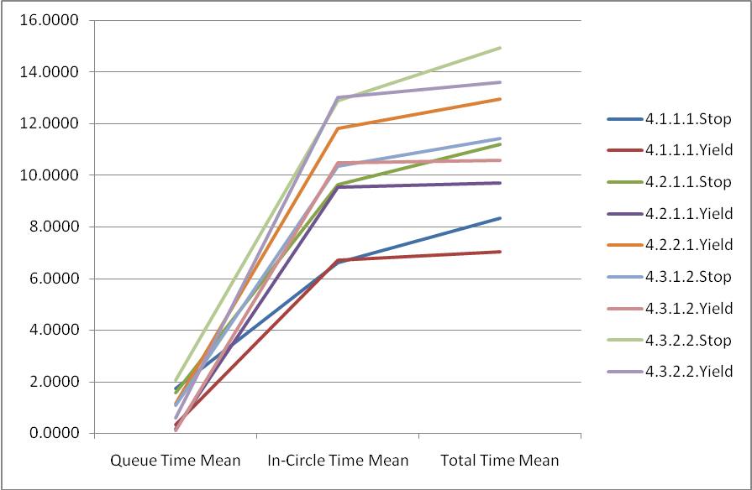
Afternoon Rush
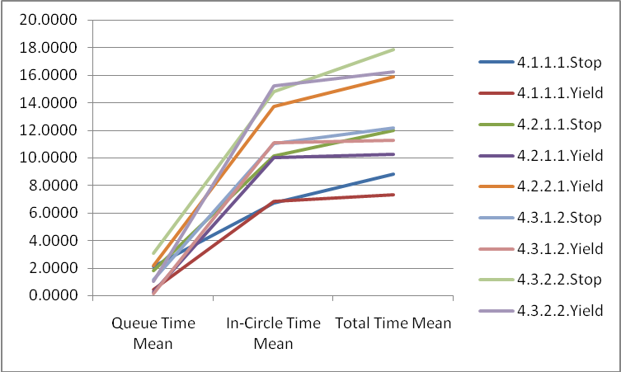
All Day
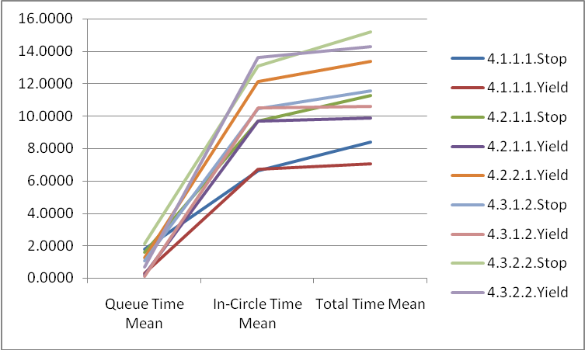

Morning
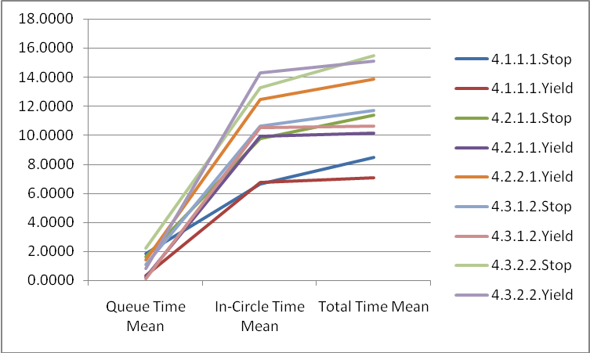

Morning rush
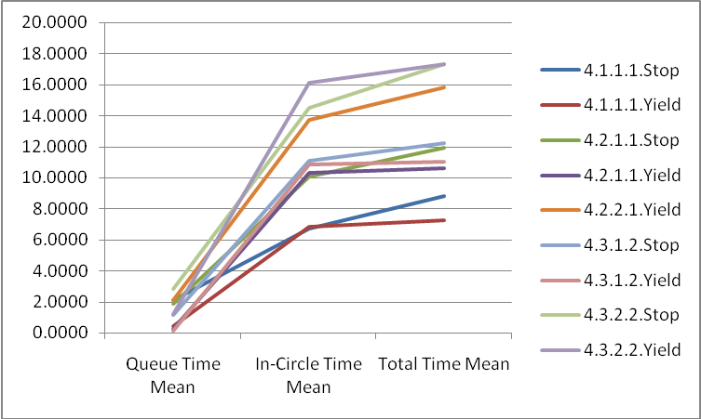

Poisson
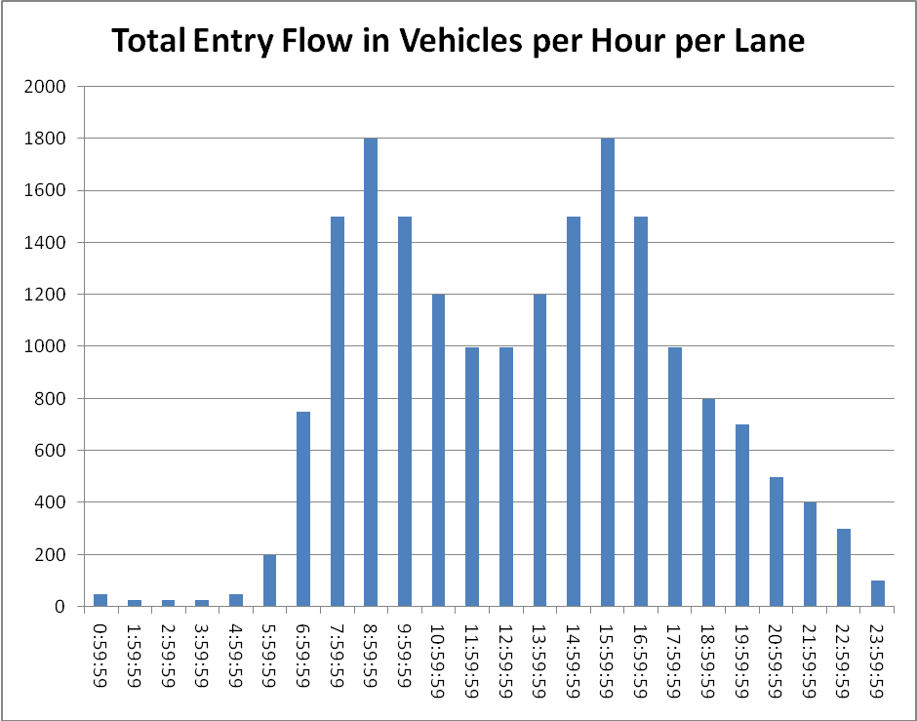
Appendix B: Program Code
// file Main.java

/** This is the main class for running the traffic circle simulation
* @author Jerod Lass
* @since Feb 6, 2009
*/

package trafficsim;

import java.io.*;

public class Main {

/** Main method*/
public static void main(String[] args){
BufferedReader x = new BufferedReader(new InputStreamReader(System.in));

System.out.println("Please input the options for the traffic circle: \n");
// try{
//String opts = x.readLine();

//create traffic circle
TrafficCircle mycircle = new TrafficCircle(3,4,0,TrafficCircle.INCOMING_YIELD,32,0,false,2);
//start sim
mycircle.run(20);
//output results

//x.readLine();
//}catch(Exception ex){
// System.out.println("Exception in main method!\n" + ex.toString());
// }
}

}

// file Car.java

/** This class is a data structure representing a car in a traffic circle
* @author Jerod Lass
* @since Feb 6, 2009
*/

package trafficsim;

import java.util.*;

public class Car {
public int intersection;
public int destination;
public int lane;
public int pos;
public int nextlane;
public int nextpos;
public int changespeed;
public int distance;
public int num;
public int speed;
public double time;
public int missedexits;
public int failedmerges;
public double queuetime;
public boolean random;
public float toGo;

/** Constructor for a car with a randomly-chosen destination
* @param inter the starting intersection
* @param sects a list of the intersections from which to randomly choose a destination
* @param number the car identifier integer
* @param rand whether or not the car was randomly placed to begin with
*/
public Car(int inter, int sects, int number, boolean rand){
intersection = inter;
pos = -1;
time = queuetime = 0;
num = number;
failedmerges = 0;
missedexits = 0;
changespeed = 0;
random = rand;
speed = 0;
distance = 0;
toGo = 150;

destination = TrafficCircle.rand.nextInt(sects);
while(destination == intersection){
destination = TrafficCircle.rand.nextInt(sects);

}
if(TrafficCircle.rand.nextInt((sects*5)) == 0 ){
destination = intersection;
}
}

/** Constructor for a random starting car
* @param sects the destination intersection
* @param number the car identifier integer
* @param cells number of cells to appear in
* @param lns number of lanes to appear in
* @param rand whether or not the car was randomly placed to begin with
* */

public Car(int sects, int number, int cells, int lns, boolean rand){
time = queuetime = 0;
num = number;
failedmerges = 0;
missedexits = 0;

random = rand;
changespeed = 0;
speed = 1;
distance = 0;
toGo = 150;

intersection = TrafficCircle.rand.nextInt(sects);
destination = TrafficCircle.rand.nextInt(sects);
while(destination == intersection){
destination = TrafficCircle.rand.nextInt(sects);

}
pos = TrafficCircle.rand.nextInt(cells);
lane = TrafficCircle.rand.nextInt(lns);

}

/**
* @return the intersection
*/
public int getIntersection() {
return intersection;
}

/**
* @param intersection the intersection to set
*/
public void setIntersection(int intersection) {
this.intersection = intersection;
}

/**
* @return the destination
*/
public int getDestination() {
return destination;
}

/**
* @param destination the destination to set
*/
public void setDestination(int destination) {
this.destination = destination;
}

/**
* @return the lane
*/
public int getLane() {
return lane;
}

public void incrLane(){
lane = lane+1;
}

/**
* @param lane the lane to set
*/
public void setLane(int lane) {
this.lane = lane;
}

/**
* @return the pos
*/
public int getPos() {
return pos;
}

public void incrPos(){
pos = (pos+1)%TrafficCircle.calcCells(this.lane);
}

/**
* @param pos the pos to set
*/
public void setPos(int pos) {
this.pos = pos;
}

public void randPos(){
pos = TrafficCircle.rand.nextInt(TrafficCircle.calcCells(this.lane));
lane = TrafficCircle.rand.nextInt(TrafficCircle.lanes);
}

/**
* @return the num
*/
public int getNum() {
return num;
}

/**
* @param num the num to set
*/
public void setNum(int num) {
this.num = num;
}

/**
* @return the time
*/
public double getTime() {
return time;
}

/**
* @param time the time to set
*/
public void setTime(double time) {
this.time = time;
}

public void incrTime(){
time++;
}

public void acceptNextPos(){
pos = nextpos;
lane = nextlane;
}

}

// file Intersection.java

/** This class is a data structure representing an intersection in a traffic circle
* @author Jerod Lass
* @since Feb 6, 2009
*/

package trafficsim;

import java.util.*;

public class Intersection {
public int number;
public int type;
public int enterCell;
public int exitCell;
public boolean stopped;
public boolean stopped2;
public List<Car> cars;

/** Constructor for an intersection
* @param number the intersection position
*/
public Intersection(int pos, int entercell){
cars = new ArrayList<Car>();
number = pos;
enterCell = entercell;
stopped = false;
stopped2 = false;
if(enterCell == 0){
exitCell = TrafficCircle.calcCells(0)-1;
}
else{
exitCell = enterCell-1;
}
}

/**
* @return the position
*/
public int getPosition() {
return number;
}

/**
* @param position the position to set
*/
public void setPosition(int position) {
this.number = position;
}

/**
* @return the type
*/
public int getType() {
return type;
}

/**
* @param type the type to set
*/
public void setType(int type) {
this.type = type;
}

/**
* @return the cars
*/
public List<Car> getCars() {
return cars;
}

/**
* @param cars the cars to set
*/
public void setCars(List<Car> cars) {
this.cars = cars;
}

/**
* @return the enterCell
*/
public int getEnterCell() {
return enterCell;
}

/**
* @param enterCell the enterCell to set
*/
public void setEnterCell(int enterCell) {
this.enterCell = enterCell;
}

/**
* @return the exitCell
*/
public int getExitCell() {
return exitCell;
}

/**
* @param exitCell the exitCell to set
*/
public void setExitCell(int exitCell) {
this.exitCell = exitCell;
}
}

/*
* To change this template, choose Tools | Templates
* and open the template in the editor.
*/

package trafficsim;

import java.util.*;
import java.io.*;
import java.lang.Math;

/**
*
* @author Jerod Lass
*/
class TrafficCircle {
public static final int INCOMING_YIELD = 0;
public static final int CIRCLE_YIELD = 1;
public static final int INCOMING_LIGHT = 2;
public static final int INCOMING_STOP = 3;
public static final int maxSpeed = 4;
public static final Random rand = new Random(new Date().getTime());

BufferedReader console = new BufferedReader(new InputStreamReader(System.in));
File poisson = new File("C:/tools/CPH.4.1.csv");

public List<Car> cars;
public static List<Intersection> intersections;
public int carIndex;
public static int intersects;
public int type;
public int concurrentFinished;
public float concurrentQueue;
public float concurrentTime;
public static int lanes;
public boolean debug;
public static int mincells;
public File output;
public int inFromQ;

/**
* Constructor for a TrafficCircle
*
* @param numLanes the number of lanes in the circle
* @param sections the number of incoming intersections
* @param sectCars the number of cars to start in each intersection
* @param ctype the traffic circle type
* @param innerCells the number of car cells in the inner-most circle
* @param startingcars the number of cars already in the circle
* @param bug whether or not to show debug output
* @param inFromQueue the number of lanes coming in at each intersection
*/
public TrafficCircle(int numLanes, int sections, int sectcars, int ctype, int innercells, int startingcars, boolean bug, int inFromQueue){
cars = new ArrayList<Car>();
intersections = new ArrayList<Intersection>();
intersects = sections;
lanes = numLanes;
type = ctype;
inFromQ = inFromQueue;
debug = bug
concurrentFinished = 0;
concurrentQueue = 0;
concurrentTime = 0;
output = new File("c:/tools/output.4.3.1.2.Y.csv");
if(output.exists()) output.write("");
mincells = innercells;
carIndex=0;
Car temp;
for(int i = 0; i < startingcars; i++){
temp = new Car(intersects,carIndex++,mincells,lanes, true);
while(getCar(temp.getLane(),temp.getPos(),true) != null){
temp.randPos();
}
cars.add(temp);
}
Intersection newSect;
for(int i= 0; i < intersects; i++){
newSect = new Intersection(i, (int) (calcCells(0)/intersects)*i);

for(int j = 0; j < sectcars; j++){
newSect.getCars().add(new Car(i, intersects, carIndex++, false));
}
intersections.add(newSect);
}
}

/**
* Method to run a simulation for a given amount of time units
* @param time the amount of time units to run the simulation
*/
public void run(int time){
if(debug){
System.out.println("Initial circle map:\n"+ this.toString());
try{console.readLine();}
catch(IOException ex){}
}

double totalTime = 0;
double totalQueue = 0;
Car temp;
List<Integer> done;
List<Car> occupants;

//start time unit iteration
int t = 0;
while(t < 86400){
t++;
if((t % 3600) == 0){
println "RealTime: ${new Date().getMinutes()}, starting GC"
System.gc();
println "Time: ${(t/3600)} hours"
System.out.println("After time iteration " + t + ":\n"+ this.toString());
System.out.println("Avg hourly total time = "
+ ((totalTime-concurrentTime)/((carIndex - numActive()) - concurrentFinished)) + "\nAvg hourly queue time = "
+ ((totalQueue-concurrentQueue)/((carIndex - numActive()) - concurrentFinished)) + ".\n");
println "Car index = $carIndex, active = ${numActive()}, totTime = $totalTime, totQueue = $totalQueue, concTime = $concurrentTime, concQ = $concurrentQueue, concFin = $concurrentFinished"
concurrentTime = totalTime;
concurrentQueue = totalQueue;
concurrentFinished = carIndex - numActive();
}

// generate new cars based on poisson probability table
int gencars;
intersections.each{sec->
gencars = poissonDist(t);
for(int i = 0; i < gencars; i++){
sec.getCars().add(new Car(sec.number, intersects,carIndex++,false));
}
}

//increment time for active cars at the top of each iteration
for(int i = 0; i < cars.size(); i++){
cars.get(i).incrTime();
}

//
// handle cars in a circle where insiders have right-of-way
//
if(type == INCOMING_YIELD || type == INCOMING_STOP){
done = new ArrayList<Integer>();
int startCarPos;
int startCarLane;
Car check;
float tempdist;
float exitmargin;

//
// Phase 1 - cars determine their desired next positions based
// on their current positions and speeds
//
boolean willExit = false;
int laneChange;
cars.eachWithIndex{ car, ind ->
check = null;
laneChange = 0;
willExit = false;
//determine if car will exit
if(car.lane == 0){
if(car.pos == (intersections.get(car.destination).exitCell)){
willExit = true;
car.nextpos = -1;
}
else{
for(int i = 1; i < car.speed; i++){
if(((car.pos + i)%calcCells(car.lane)) == intersections.get(car.destination).exitCell){
willExit = true;
car.nextpos = -1;
}
}
}
}

//handle exit/nextposition
if(willExit){
totalTime += car.getTime();
totalQueue += car.queuetime;
if(debug) println "\nCar " + car.num + " finished after " + car.getTime() + " time units, " + car.queuetime + " in the queue.\n"
output.append("${t},${car.num},${car.intersection},${car.destination},${car.queuetime},${car.time}\n");
done.add(ind);
}
else{
if(debug) println "Getting distance... lane 0 space ${intersections.get(car.destination).exitCell} projected onto lane ${car.lane}"
tempdist = findDistance(car.pos, projectCell(0,intersections.get(car.destination).exitCell,car.lane),car.lane);
tempdist = tempdist/((float) calcCells(car.lane));
if(car.toGo < tempdist) car.missedexits += 1;
car.toGo = tempdist;
//determine if a car wants to change lanes
if(lanes > 1){
if((car.lane == 0)){
if((car.missedexits == 0)){
if( tempdist < ((float) 1/intersects )){
laneChange = 0;
}
else{
laneChange = 1;
}
}
else{
laneChange = 0;
}
}
else{
if((car.missedexits == 0)){

exitmargin = (0.5 + (0.5 * car.lane))/intersects;

if(tempdist < exitmargin){
laneChange = -1;
}
else if(tempdist < 0.5){
laneChange = 0;
}
else{
if(car.lane < (lanes-1))laneChange = 1;
}
}
else if((car.missedexits == 1)){
if(tempdist < 0.75){
laneChange = -1;
}
else{
laneChange = 0;
}
}
else{
laneChange = -1;
}
}
}

//determine if a car can change lanes
if(laneChange != 0){
if(getCar((car.lane + laneChange), projectCell(car.lane, car.pos, (laneChange>0)), false) == null){

check = getCar((car.lane + laneChange), projectCell(car.lane, ((car.pos+1)%(calcCells(car.lane))), (laneChange>0)), false);
if((check != null) && (check.speed <= car.speed)){
laneChange = 0;
}

check = getCar((car.lane + laneChange), projectCell(car.lane, ((car.pos+11)%(calcCells(car.lane))), (laneChange>0)), false);
if((check != null) && (check.speed >= car.speed)){
laneChange = 0;
}
}
else laneChange = 0;
}
//lane change pre-check is complete. adjust new desired position
if(laneChange == 0){
car.distance = car.speed;
car.nextpos = (car.pos + car.speed) % (calcCells(car.lane));
car.nextlane = car.lane;
}
else{
car.nextpos = (car.pos + car.speed) % (calcCells(car.lane));
car.nextpos = projectCell(car.lane,car.nextpos,(laneChange>0));
car.distance = car.speed + maxSpeed + 1;
car.nextlane = car.lane+laneChange;
}
if(debug){
if(laneChange == 0) println "Car ${car.num}: lane ${car.lane}, distance $tempdist, away missed ${car.missedexits} exits, failed ${car.failedmerges} merges. NOT MERGING";
else println "Car ${car.num}: lane ${car.lane}, distance $tempdist, away missed ${car.missedexits} exits, failed ${car.failedmerges} merges. MERGING";
}
}
}

//
// Phase 2 - assess and correct errors
//
Car closest;
for(int cell = (calcCells(0)-1); cell >= 0; cell--){
for(int ln = 0; ln < lanes; ln++ ){
occupants = new ArrayList<Car>();
boolean letIn = false;

cars.each{car->
if(((car.nextpos == projectCell(0,cell,Math.abs(ln))) || (car.nextpos == ((projectCell(0,cell,Math.abs(ln))+1)%calcCells(ln))) ) && (car.nextlane == ln)) occupants.add(car);
}

if(occupants.size() > 1){
String resultStr = "\nCollision at Lane $ln, Cell ${projectCell(0,cell,ln)} involving: ";
closest = null;
if((occupants.size() == 2) &&
(((occupants.get(0).distance > maxSpeed) && (occupants.get(1).distance <= maxSpeed)) ||
((occupants.get(0).distance <= maxSpeed) && (occupants.get(1).distance > maxSpeed))) ){
Car occ1 = occupants.get(1);
Car occ0 = occupants.get(0);
Car tempcar;
int bottomspeed;
if(occ1.nextpos == occ0.nextpos) bottomspeed = 3;
else bottomspeed = 2;
if(occ1.distance <= maxSpeed){
tempcar = occ0;
occ0 = occ1;
occ1 = tempcar;
}
if((occ0.speed >= bottomspeed) && (rand.nextInt(100) < (20/(occ0.speed)))){
resultStr += " ${occ0.num} and ${occ1.num} but there was a let-in"
letIn = true;
occ0.nextpos = (occ0.pos + (occ0.speed-(bottomspeed-1))) % calcCells(occ0.lane);
}
}
if(!letIn){
occupants.each{car->
resultStr += " ${car.num}, "
if(car.distance > maxSpeed){
car.nextlane = car.lane;
car.nextpos = (car.pos + car.speed) % (calcCells(car.lane));
car.failedmerges += 1;
}
else if(closest == null) closest = car;
else{
if(car.distance < closest.distance){
//closest backs off
closest.nextpos = (closest.pos + closest.speed - 1)%calcCells(closest.lane);
}
else{
//current car backs off
car.nextpos = (car.pos + car.speed - 1)%calcCells(car.lane);
}
}
}
}

resultStr += "\n";
if(debug) println resultStr
}
}
for(int ln = (lanes-2); ln >= 0 ; ln-- ){
occupants = new ArrayList<Car>();

cars.each{car->
if((car.nextpos == projectCell(0,cell,Math.abs(ln))) && (car.nextlane == ln)) occupants.add(car);
}

if(occupants.size() > 1){
closest = null;
cars.each{car->
if(car.distance > maxSpeed){
car.nextlane = car.lane;
car.nextpos = (car.pos + car.speed) % (calcCells(car.lane));
car.failedmerges += 1;
}
else if(closest == null) closest = car;
else{
if(car.distance < closest.distance){
//closest backs off
closest.nextpos = (closest.pos + closest.speed - 1)%calcCells(closest.lane);
}
else{
//current car backs off
car.nextpos = (car.pos + car.speed - 1)%calcCells(car.lane);
}
}
}
}
}
}

//errors fixed - accept new positions
cars.each{car->
car.acceptNextPos();
}

//remove finished cars from cars list
done.reverseEach{
cars.remove(it);
}

//
// Phase 3 - let new cars in from intersections where applicable
//

for(int i = 0; i < intersects; i++){
if((getCar(0, intersections.get(i).getEnterCell(),true) == null) && (!(intersections.get(i).getCars().isEmpty()))){
if(!(intersections.get(i).stopped) && (type == INCOMING_STOP) && !(intersections.get(i).stopped2)) intersections.get(i).stopped = intersections.get(i).stopped2 = true;
else{

if(intersections.get(i).stopped || (type == INCOMING_YIELD)){
temp = intersections.get(i).getCars().get(0);
temp.setPos(intersections.get(i).getEnterCell());
temp.setLane(0);
temp.speed = 1;
temp.queuetime = temp.time;
temp.time += 2;
temp.toGo = findDistance(temp.pos, intersections.get(temp.destination).exitCell, 0)/calcCells(0);
cars.add(temp);
intersections.get(i).getCars().remove(0);
intersections.get(i).stopped = false;
}
else intersections.get(i).stopped = true;

if((inFromQ == 2) && ((intersections.get(i).stopped2) || (type == INCOMING_YIELD))){
int pcell = projectCell(0,intersections.get(i).enterCell,1);
if(getCar(1,pcell,true) == null){
int index = 0;
while((intersections.get(i).cars.size() > index) && (Math.abs(intersections.get(i).getCars().get(index).destination - i) != 1) && (Math.abs(intersections.get(i).getCars().get(index).destination - i) != (-1*(intersects-1)))){
index++;
}
if(index < intersections.get(i).cars.size()){
temp = intersections.get(i).getCars().get(index);
temp.setPos(pcell);
temp.setLane(1);
temp.speed = 1;
temp.queuetime = temp.time;
temp.time += 2;
temp.toGo = findDistance(temp.pos, projectCell(0,intersections.get(temp.destination).exitCell,1), 1)/calcCells(1);
cars.add(temp);
intersections.get(i).getCars().remove(index);
intersections.get(i).stopped2 = false;
}
else{
intersections.get(i).stopped2 = false;
}
}
}
else intersections.get(i).stopped2 = true;
}
}
}

//
// Phase 4 - recalculate speed based on surroundings
//

//configure new speeds
int targetSpeed;
cars.each{car->
targetSpeed = 1;
while((getCar(car.lane, ((car.pos+targetSpeed)%calcCells(car.lane)), false) == null)
&& ((targetSpeed - car.speed)<1)){
targetSpeed++;
}

if(targetSpeed <= maxSpeed) car.speed = targetSpeed;
else car.speed = maxSpeed;
}

//increment time for cars still in the queue
List<Car> sectcars;
for(int i = 0; i < intersects; i++){
sectcars = intersections.get(i).getCars();
for(int j = 0; j < sectcars.size(); j++){
sectcars.get(j).incrTime();
}
}

}

if(debug) {
System.out.println("After time iteration " + t + ":\n"+ this.toString());

try{
if(console.readLine().equals("exit")){
return;
}
}
catch(Exception ex){}
}
}

System.out.println("Done after time iteration " + t + ".\nAvg total time = "
+ (totalTime/(carIndex - numActive())) + "\nAvg queue time = "
+ (totalQueue/(carIndex - numActive())) + ".\n");
System.out.println("After time iteration " + t + ":\n"+ this.toString());
}

Car getCar(int lane, int cell, boolean merge){
int check;

if(merge == true) check = -1;
else check = 0;
int checkSpace;
for(int i = 0; i < cars.size(); i++){
for(int j = check; j < 2; j++){
checkSpace = (cell+j)%calcCells(lane);
if(checkSpace == -1) checkSpace = calcCells(lane)-1;
if((cars.get(i).getLane() == lane) && (cars.get(i).getPos() == checkSpace)){
return cars.get(i);
}
}
}

return null;
}

public String toString(){
String output = "\n";

Car temp;

for(int i = 0; i < lanes; i ++){
output += "\nLane " + i + ":\t";
for(int cell = 0; cell < calcCells(i); cell++){
temp = getCar(i, cell, false);
if(temp != null){
output += "" + temp.getNum() + ":" + temp.getDestination() + ":" + temp.speed + " ";
temp=null;
}
else{
output += "-: : ";
}
}
}

output += "\n\n";

for(int inter = 0; inter < intersects; inter++){
output += "Intersection " + inter + " queue: " + intersections.get(inter).getCars().size() + " cars\n";
}

return output;
}

int numActive(){
int actives = cars.size;

intersections.each{sec->
actives += sec.getCars().size;
}

return actives;
}

public static int calcCells(int lanenum){
return (mincells + (8*(lanes - lanenum - 1)));
}

int projectCell(int startLane, int startCell, boolean moveIn){
if(moveIn){
return ((int) ((startCell/calcCells(startLane))*calcCells(startLane+1)));
}
else{
return ((int) ((startCell/calcCells(startLane))*calcCells(startLane-1)));
}
}

int projectCell(int startLane, int startCell, int newLane){
return ( (int) ( ( ((float) startCell) / ((float) calcCells(startLane)) ) * ((float) calcCells(newLane)) ) );
}

int findDistance(int start, int end, int lane){
int laneCapac = calcCells(lane);
int distance;

if(start > end){
distance = ((laneCapac - start) + end);
}
else{
distance = (end-start);
}

return distance;
}

int poissonDist(int ptime){
//poisson .csv format must be:
// startTime,endTime,pval1,pval2,carsToGenerate,CDF

float index = rand.nextFloat();

StringTokenizer tok;
int startTime;
int gencars = 0;
int returncars = -1;
float prob;
poisson.eachLine{line->
tok = new StringTokenizer(line,",");
startTime = Integer.parseInt(tok.nextToken());
if((startTime <= ptime) && (Integer.parseInt(tok.nextToken()) >= ptime)){
tok.nextToken();
gencars = Integer.parseInt(tok.nextToken());
//println "gencars: ${gencars}"

prob = Float.parseFloat(tok.nextToken())
if((prob >= index) && (returncars == -1)){
//println "prob ${prob} found in table"
returncars = gencars;
}
}
//otherwise, if the beginning time is greater than the current time, our probability exceeded the maximum
// of all registered poisson probabilities and we return gencars+1 where gencars is the highest registered # of cars
else if((startTime > ptime) && (returncars == -1)){
returncars = gencars+1;
}

}
if(returncars == -1){
return 0;
}
else{
return returncars;
}
}

}
Appendix C: Results Tables

Attached in a different file

