ADDED Information
Red = information to check, change, or eliminate
47

North Dakota

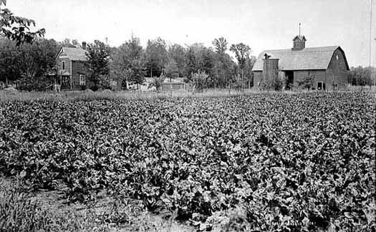
Sugar beet field and farm
Photographer: Charles J. Hibbard (-1924)
Photograph Collection 1911
Location no. SA2.1 p40
Negative no. 56778
Minnesota Historical Society

(41-6) There was an Indian there [by Boy River, Jim Mitchell.] He didn't know a word of English. All he was was a typical Indian, when we first met him. [add footnote: “Typical” = traditional.] He married my sister. He was a good worker, a willing one. One time he took off to North Dakota with a gang. That was in the 1930s. When he got out in North Dakota, he got on the threshing machine, field pitching. Boy, he liked it there so much! They fed him good, and he had a good place to sleep. He was making good money too. I think they were getting four, five dollars a day, them days [for working in the field.]
He stayed there quite a while. Everybody [else] quit, since they were getting through harvesting. But they [the farmer he was workin’ for] had a little patch to thresh yet, so he stayed. He helped them through to the end.
When they were done the farmer said, "I'll take you to town."
It was about thirty miles to town.
"I'll take you to town, Jim. Don't worry. I'll take care of you."
"All right." [“OK.”]
(41-7) The truth was that Jim didn't know where he was, and didn't know what to say, you know, because he didn't have any school. But the best farmer [of that area] took parts for him and took good care of him. The farmer felt like taking his [Jim’s] part, taking care of him, because he was a good worker. He did take care of him too.
It happened that when they got through with the threshing and had everything all cleaned up, the farmer said, "Well, Jim, if you want to go to town tomorrow, I'll take you. If you get ready tonight, you can go home tomorrow. I'll have your money. I'll write your check, and we'll go to town, go in the bank and we'll cash that check. You'll get every cent."
Why he [Jim] didn't know how much he had coming! No. To get a hundred dollars those days was doing something. A hundred dollars was big money, and he had over a hundred dollars. He was telling me that himself. He was telling me the experience he had going out to Dakota. He said, "I was out there all alone, with no Indian to talk to. All I could hear is English. All I could say is 'no,' 'yes.'"
So Jim was way out there in North Dakota, and when the farmer pulled into town he took him right in the bank and cashed his check. He [Jim] stood right there and the banker counted out the money to him. He [The banker] took the money and put it in an envelope. It was all new money. Jim had a billfold on him, but gee, all that money couldn't fit in it. So [the farmer took the money and] he told Jim, "OK, Jim, let's go."
The banker didn't know who had the money.
(41-8) If he knew Jim had it, there might-a been a play in that. It was safer because they [the people at the bank] didn't know who had the money. So the farmer took Jim down to the train.
When Jim got home he was telling me how well they took care of him, and how dangerous it was around there. He told me about all the staggers which stagged toward him. They'd try to talk to him, but he couldn't talk because he didn't know English. And besides that, he wasn't a drinking man.
Well, the farmer went into the ticket office and bought a ticket home, for Jim. The train was coming and the guy took that envelope and stuck it in Jim's hand. He handed it to Jim, "Here's your money. Don't open it until you get home. I'll give you this other money to buy your meal." He had another five left after he bought a ticket and he gave it to Jim for a meal. "And come back next fall, Jim. You're a sticker. You're very good. You done a very good job. I hate to lose you, Jim. You're a good man -- for an Indian. I'm sorry you can't talk English." Jim shook hands with him, and he came home.
On his way home he didn't want to show this envelope to anyone. He always had good clothes, like suits and everything, and he had suitcases. So, he put the envelope in his suit or in his suitcase until he got off the train. I think he got off at Boy River. He belonged over there somewhere, and he went there somewhere to the wigwam where he stayed. I think it was the wigwam of one of my sisters, or somewhere close by there. After awhile he was married to my sister. But when I'm talking about Dakota, I'm talking about before he was married to her. He had a crush on my sister when he went to Dakota.
(41-9) When he got to whatever wigwam he was going to, he opened this envelope, because he was in a private place. He was in a private room with himself. He said he didn't ever see so much money as he did there. "Boy, he said, I pred'ner dropped when I opened that envelope." He said all he could see was "...tens, tens, tens, tens." There was somewhere around two hundred dollars in there, a hundred and something, but about two hundred dollars. Inside the envelope there was a little slip in there telling how many hours, and so many days, he worked, and the balance he was owed was on there too. And at the bottom it read, "Good luck to you."
Boy [that farmer] he must have been a good farmer. He thought the world of that boy, for an Indian. Jim thought the world of him too. Poor kid.
Oh, about the thirties, about thirty-two, about in the thirties, yea, ah, twenty-six, twenty-seven, yea, [That was] about twenty-six or twenty-seven [; about in the thirties,yea.] They were good farmers too, those days. Boy I tell you that farmer took care of Jim and sent him home like a man. Yep. Jim was a clean Indian, and led a clean sort of a life. He was a nice fellow. Jim made it all the time. He always wanted to go out there again, but he said, "I don't think I could find that place."
That was something for him to be alone out there in Dakota, and he stuck right with them 'till the snow flied.
(41-10) Jim started, around Crookston, shocking oats. He went out there to Dakota after the Fourth. After the Fourth of July we used to go up there to shock oats. We'd get all kinds of shocking in after the Fourth. And that's when Jim went, and he stayed 'till the snow flied.
We'd shock a little short oats around here, ‘round Ball Club [and Deer River]. We'd do that, and after we'd get through here, then we'd go north to North Dakota.

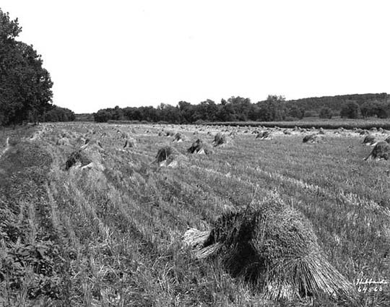
Oats shocks in field.
Photographer: Hibbard Studio
Photograph Collection 8/17/1926
Location no. SA4.52 p109
Negative no. NP64560
Minnesota Historical Society

Xxx Well,s Short oats ripens too early because of the heat of the ground and because the grain isn't planted too early [late]. So the further west you go, the better material of oats or grain you get. That's where they get moisture. The grain grows heavier further west. It's well fertilized there too. But [around Ball Club] the short oats is planted in sandy areas, mostly sandy areas, and that doesn't work too well. But anyhow, [around here] they got enough to take care of their cattle. zzz These small fields were just big enough to feed their local cattle for the winters. [And here the] cattle does a lot of work for the fertilizing of the area. Xxx Zzz That's why [what] they use [for] fertilizer [around here], natural fertilizer. Zzz
[78-13] A little bit later on lots of people took their teams [of horses] out there [to Dakota]. We used to load horses to take with us too, because they didn't have enough horses in North Dakota. There used to be a guy around Ball Club who ordered a couple boxcars to load horses. He'd put them in there [the boxcars] and take them to Dakota and hire those horses out right there. He'd take them out to Dakota and put them on the binders and threshing rigs. He'd take the wagons too, wheels and all. He'd take them apart and put them together up there. That's all Godfrey (sp?) ever done was hire horses. Yah.
That was the Old Man Godfrey, Charlie Godfrey's dad. Yea. Einerd or Morse Godfrey. xxx [Afterwards,] old Fred Hawkens had three, four teams to be hired out afterwards. Zzz

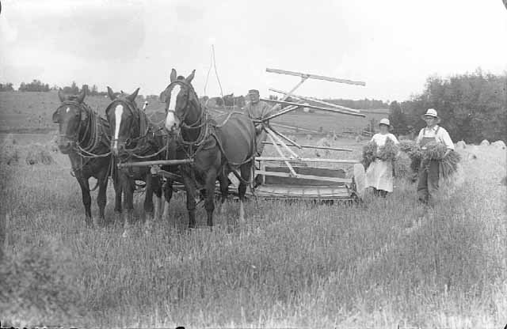
Three horse team and binder.
Photographer: Henry A. Briol
Photograph Collection 1931
Location no. SA4.51 r86
Negative no. 11128-A
Minnesota Historical Society
It got so that everybody had figured that Dakota wasn't very far. It was a couple hundred miles or something.
(41-11) One Frenchman said, "I'll make that with my team." Instead of hiring a boxcar and renting horses out when he got there, and instead of putting them on the boxcar to move them out there, he wanted to drive his own horses to Dakota. So, he drove them up. When he got half way, one of the horses played out and died on the road. And there he was, with that second pole tied up on the hames of his one horse, and that one old horse was pulling that god damn wagon with a load on, camping outfit and all. I don't know how far he got before he finally found a pretty cheap horse up there that was nothing but a rack and bones. He put the harness on that other one and he made a team and finally got up there.

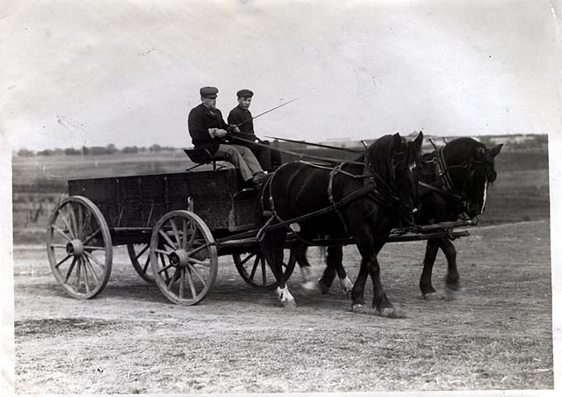
Men in horse drawn wagon.
Photograph Collection ca. 1910
Location no. HE2.3 r59
Minnesota Historical Society

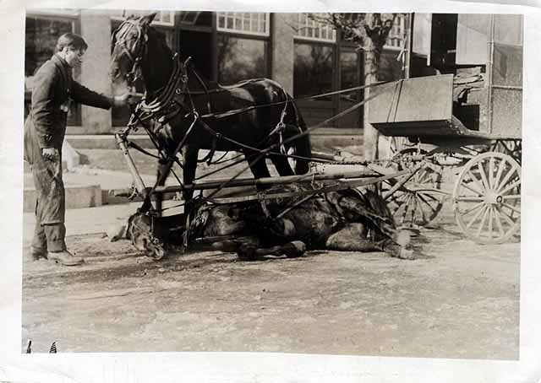
Horse, pulling delivery wagon, suffering from overwork.
Photographer: Harry Darius Ayer (1878-1966)
Photograph Collection ca. 1910
Location no. HE2.3 r38
Negative no. 62914
Minnesota Historical Society

[78-11][78-12] Xxx Speaking about it generally, Indians from Ball Club went out to the Dakotas, oh, about, starting about around eighteen -- eighteen or twelve. And what year did The first ones go to Dakota from Ball Club [went in about … ] that was, oh boy, that was about, I'll say, I should judge about -- for my part I should judge -- it was about nineteen-seven. They were working with small fields [then] you know. Xxx Then At that time they raised cattle and they had to buy more ground. Huh?xxx Paul, what was the first year They were working by hand [at that time], but after while the farmers there made enough to get machinery. The machinery took a lot of labor off of the hands of the laborers. So pretty soon they machined everything. When did start coming in, ? I think those machines they started to come in about around fourteen -- ten, fourteen, fifteen.

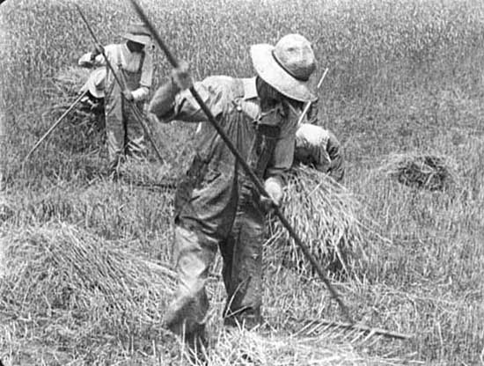
Raking hay by hand.
Photograph Collection ca. 1910
Location no. SA4.51 r35
Negative no. 86679
Minnesota Historical Society
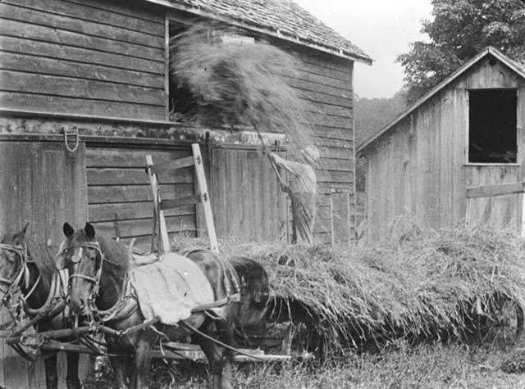
Unloading hay by hand.
Photograph Collection ca. 1915
Location no. SA4.51 r61
Negative no. 31278
Minnesota Historical Society

We liked working with those machines.

Indian Hobos
(11-34) In July, after the celebration of the 4th, some of us boys would get together -- three, four in a group -- and we would climb a freight [train] as it slowed down. If it didn't stop, it slowed down. We were active [enough] to catch a train and get on top of boxcars, flatcars, or anything we'd find. All we had was a few pennies in our pocket, a little change, enough to eat on. If we had time enough we would stop at Fosston or somewhere on the way to Grand Forks, and get a quart of milk. We'd ask the brakeman, "Could we get anything to eat?"

"Yes, you got time. We stop ten minutes."

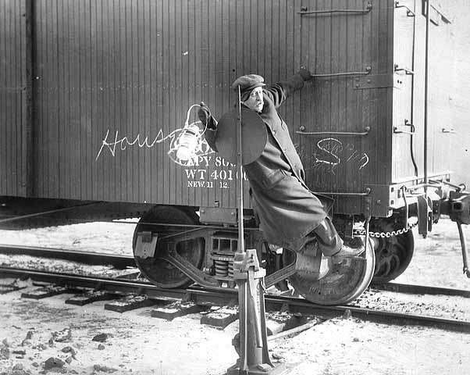
Northern Pacific switchman or brakeman giving switching signal with lighted lantern.
Photograph Collection ca. 1915
Location no. HE6.92N p13
Negative no. 43749

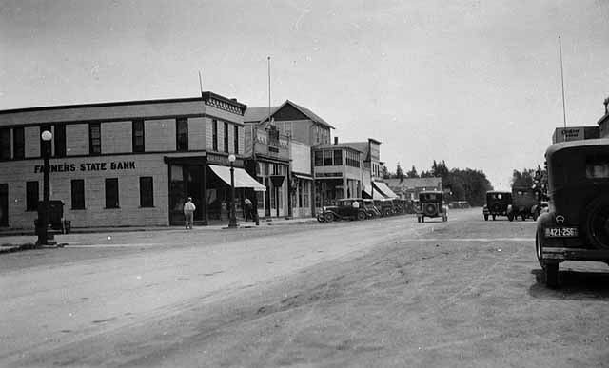
Street scene, Fosston.
Photograph Collection 1934
Location no. MP7.9 FS r2
Negative no. 57512
Minnesota Historical Society
We'd make for that grocery store and we'd get a loaf of bread and eat it on the way going. Oh, they were good to us. Generally, before we started, I'd make sure we'd get our stomachs full. That's the way we travelled. We'd get up there to Grand Forks in the evening, around evening, and we'd meet some bunch of hoboes already there waiting for a job. We'd ask them, "How's things going?"

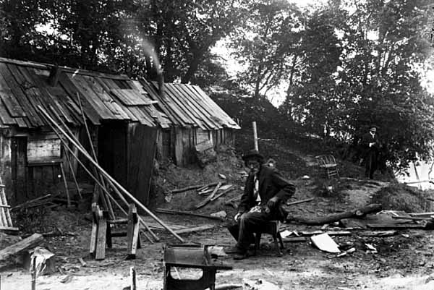
Hobo camp.
Photograph Collection ca. 1925
Location no. HV1.7 r1
Negative no. 92892
Minnesota Historical Society
"They're just goin'-a start," they'd usually say. "Times are depressed."
They'd go next to the river where they had a cooking outfit, "the jungles" they called it. They had a table there where they were cooking up. Everything was washed clean. Oh boy, if you didn't wash those dishes they'd go after you. They used tin cans, soap pails, and everything. They had forks and knives. Where they got them I don't know, but they had them. Some of them would take them along and leave them there for the hobo's life. They were already clean for us. They had big cooking kettles, usually lard cans or something.
(11-35) They'd cook in lard cans, big lard cans.
Our first worry was cooking up supper. After supper our next worry was about getting a job.
We'd crawl in some old shelter, like a box car. We'd start looking for empties in the [railroad] yard and we'd crawl in there for the evening. We'd take some old paper re-linings for the boxcars -- what they used to reline that freight and stuff -- and covered up with the old papers to keep warm. You'd wrap up in that old paper and that kept you pretty warm. Some of them had overcoats. Some of them would have sacks they used for pillows. We'd pile in and sleep good in there. We'd shut the door of the boxcar. We'd get up in the morning, go down to the river, and wash up. Everybody had their [task??xxx]. After that we'd cook up coffee again.
We drank a lot of coffee, and for supper we [most generally] had a boil. We'd go into those butcher shops and buy meat scrap. We didn't have enough money to buy anything but scraps. The butcher shop'ed give you a lot of meat scrap because they knew that you didn't have much money. They were good, some butcher shops, in those days. They'd allow a lot of meat on the soup bones. They'd say, "You gonna cook up?" And then they'd throw in something they'd want to eat too. They'd want to eat a lot of the stuff they gave us. It's no dog's life, that hobo life.

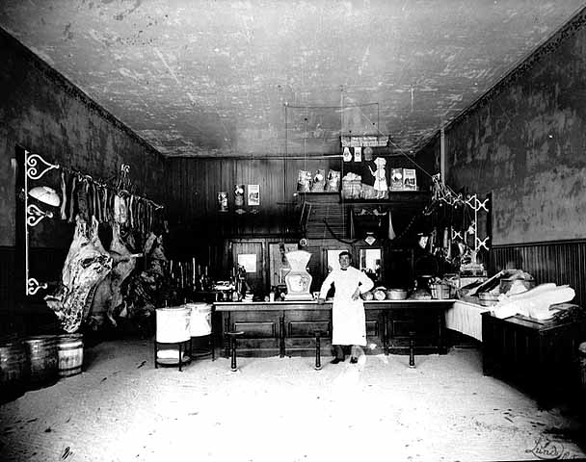
Interior of butcher shop, Dawson
Photographer: Andrew B. Lund
Photograph Collection ca. 1910
Location no. HF4.6 p27
Negative no. 24209
Minnesota Historical Society

(11-36) They'd think, "Well, here, have a good feed." Then we'd get some turnips and onions at the vegetable store and boil that up with our meat. They gave us vegetables too, if we asked for them.
"We're looking for work."
"OK."
They were pretty good to us.
"You're cooking up in the jungle?"
"Sure."
"Have a good meal."
We had a big camp, and we always had a cook along in the gang, or somebody that could cook.
For breakfast we just made coffee, and we were ready to go. We'd figure on eating on the farm. The farmers would take us out at eight, nine, ten o'clock.
"You have breakfast yet?"
"No."
Some of those farmers would take us in the restaurant and give us a big breakfast. Then they'd take us out to work.
We worked on sugar beet farms, wheat farms, and anywhere we could find work. We harvested sugar beets or anything there that was ready. We even shocked oats in the olden days.

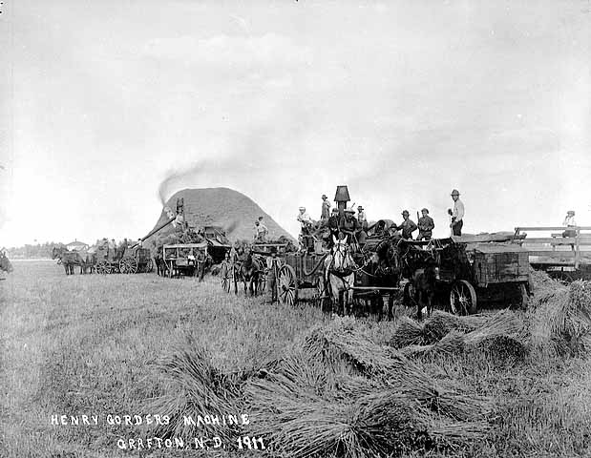
Henry Gorder's threshing machine, Grafton, North Dakota.
Photograph Collection 1911
Location no. SA4.6 p70
Negative no. 781
Minnesota Historical Society
(11-37) It took a lot of labor to harvest in those days. We had eight, nine, ten, as high as fifteen, to a threshing rig, a big old-fashioned threshing machine. Then when night fell we'd look for a place to spend the night. Well, a lot of them in those days didn't have big houses and maybe a farmer had a big family. Usually they had a barn with a lot of hay and we were satisfied to sleep in the barn. They had nice big barns. We'd take those old blankets, horse blankets, and cover up with them. They were made out of good stuff. They'd take care of their stuff, some of them farmers, to get ready for the labors. They'd give them blankets and pillows, coats, or whatever they'd need. We'd crawl in the hay and have a good sleep. We'd get up in the morning, go for breakfast -- usually coffee and oatmeal -- and go to work. You'd put in so many days like that. Some of them worked through the season. In those days they stuck to a job. It was nice, a great life. You were free to the world.

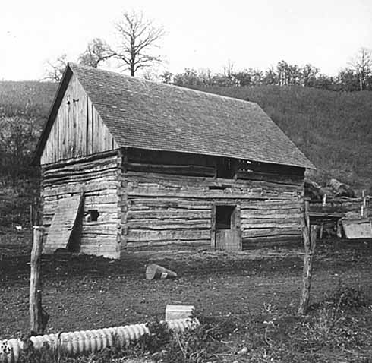
Log Barn southwest of Blakely.
Photographer: Paul W. Klammer
Photograph Collection 1940
Location no. MS5.3 p1
Negative no. 77425
Minnesota Historical Society

And the money was valued days. You didn't get much -- maybe four, five bucks a day -- but the valuation of the money on the dollar was there. And there was no income [tax] to take out.
The price of food wasn't too high, and five dollars was valued as a lot of money. That's the way we lived, a hobo life.
(11-38) Some of them would go back on the train. We had passenger trains those days. Some of them would ride the train lines back home on the passenger cars, and maybe we'd ride the boxcar back. We still would have money in our pockets when we got back home because we saved a little. It wasn't too rough along in there. It wasn't rough by all means.

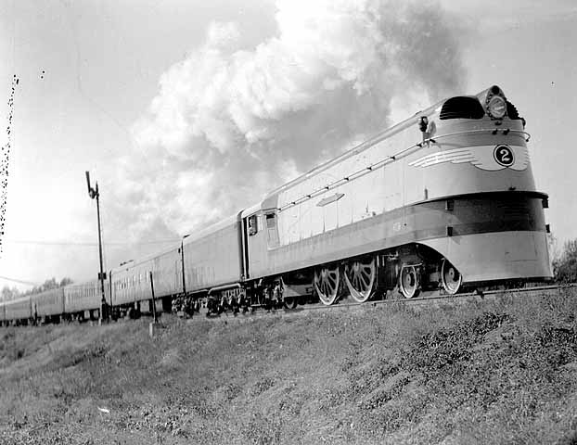
Chicago, Milwaukee, St. Paul and Pacific Railway Company's
streamlined passenger train, the Hiawatha.
Photographer: Harry Darius Ayer (1878-1966)
Photograph Collection ca. 1935
Location no. HE6.2M p6
Negative no. 28522
Minnesota Historical Society

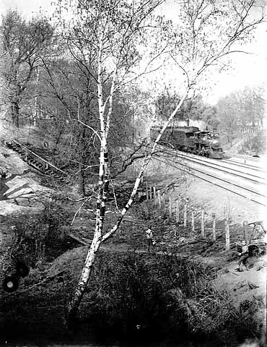
Passenger train.
Creator: Minneapolis Journal
Photograph Collection, 1900
Minnesota Historical Society
Location No. HE6.2 p11 Negative No. 59933
[xxxfrom chapter “Talking with the OldTimers”]
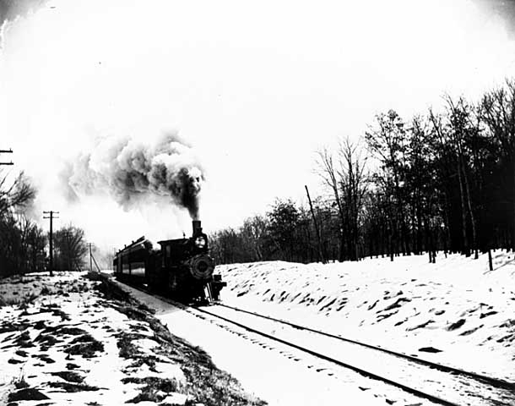
Passenger train.
Photographer: Minneapolis Journal
Photograph Collection ca. 1900
Location no. HE6.2 p5
Negative no. 3704-B

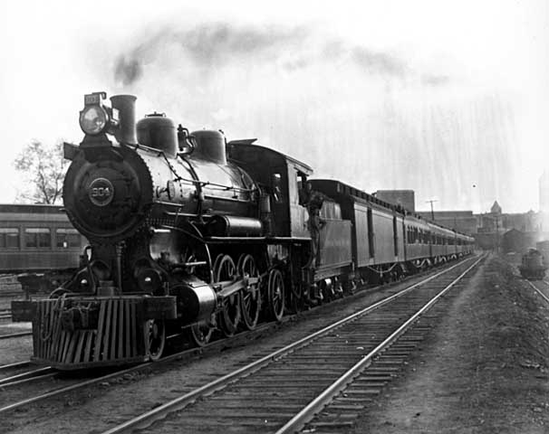
Chicago Great Western passenger train pulling out from Minneapolis Union Depot.
Photographer: Minneapolis Journal
Photograph Collection ca. 1900
Location no. HE6.2 p16
Negative no. 3688-B
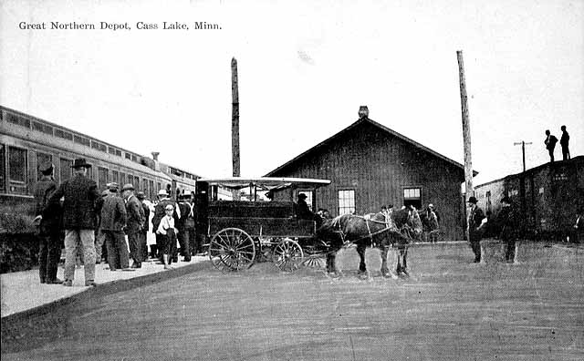
Passengers at Great Northern Depot, Cass Lake.
Photograph Collection, Postcard ca. 1910
Location no. HE6.93 r3
Negative no. 59167

We got along pretty good. They use the Indians good up there.
They didn't bother the Indian boys when we were riding the train cars. They were always nice and tried to help them. They knew we had a hard life. They knew that we were looking for something to eat all the time. And when we got something to eat we were satisfied. Some came back home with a little money, some didn't. It all depended on how much they made. Some got into a little bad luck, like rainy weather or maybe a poor crop or something. Some struck it lucky with a good crop and plenty of acreage. Those who struck it lucky got in a lot of time. Others had motor trouble -- steam engine trouble -- and couldn't get any time in. So that's the way it went. Some would come back with good clothes. They'd buy their clothes up there. We thought that was something. That was a good old way of life. All the men and young folks, the men folks, would leave for the west to labor in the Dakotas.
(11-39) I knew a lot of them who would leave for the Dakota grain just about ricing time. [xxx] I'd go from one tent to another, one camp to another. I'd ask for the [Indian] boys.
“Where have they gone?”
"Well, they left for Dakota."

[They had Siouxs in the Dakota, but we never got into trouble with the Siouxs.] No!! We got along good with them. No, the government possessed a school and a lot of them went to the government school. That helped lots. No, I don't think the Siouxs were enemies. It was our leaders, instigators, that caused the trouble.

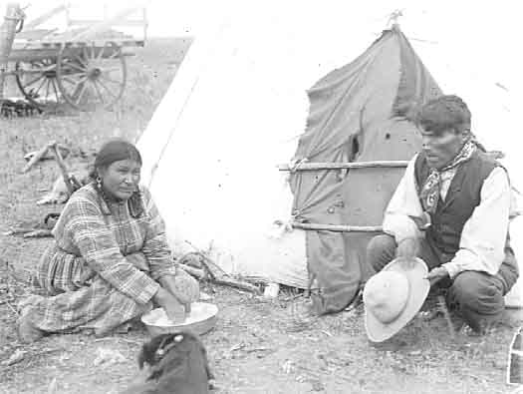
Sioux Indians, Fort Totten, Devil's Lake, North Dakota.
Photograph Collection ca. 1920
Location no. E90 r4
Negative no. 40720
Minnesota Historical Society
I say a lot of people, a lot of the Sioux tribe, don't want to fight. A lot of Indians don't want to fight. It's the leaders. They make up something and probably we have to go fight and the Sioux have to go too. That's the way it is. They never changed that way of life. The leaders tell them something that makes them think it's dangerous for them if they don't fight, and they feel they have to go.
The point of that War is talked about all the time, but individually everybody likes to be in peace. They like to sit peacefully by a campfire. I've seen a thousand people peacefully sitting in groups around campfires. All they want is plenty to eat and to see the animals. They want to see the animal wildlife and to watch birds fly. They want to see natural things growing, and to watch the rice crop growing.

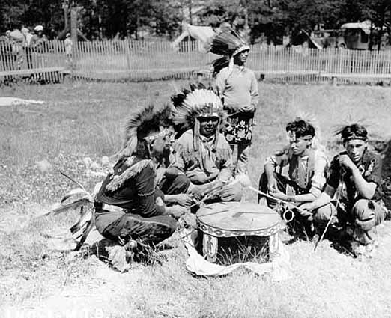
Indian drummers from Cass Lake
beating drum during celebration commemorating
peace treaty between Chippewas and Sioux, 75th anniversary.
Photographer: L. D. Eldridge
Photograph Collection 7/4/1938
Location no. E97.37 p14
Minnesota Historical Society
Negative no. 40621

(11-40) They like to look at the acorns on the trees. They ask, "How much we gonna have? That's gonna feed our animals, the deer, the bear. The deer and the bear come along in there and harvest, the same as a person. They're struggling for life, they're battling for life. They work with the Great. It's just like a hobo life. The bear and the deer have to be careful, and they're always looking for something to eat.

But then I lived, during the 1920's, I lived in Bena again for about 4 or 5 years. I made a home there by logging a little bit; I logged myself. I bought a little home through taxes. I bought nine lots and had a good home there with a yard and a good garden spot. I made a pretty good living there.
Xxx Bena add-ons from Master 3.5
Bena
(9-32) I tried that [farming there]. I lived in Bena there, right in town at Bena, and I had a little farm just to experiment. I was off from a farm and I lived in Bena, I bought a place in Bena. [Ft Nt: Cf., “Leech and Mississippi Forks”] I had two boys and a woman at that time. I said to my woman, "There's a lot here with nine lots. I'm gonna buy that."
So I bought it through the tax title. It was tax delinquent. A guy had a mortgage on it and I bought up the mortgage. I got a sheriff's notice to the guy that held the mortgage.
"Well," he told the sheriff, "I don't want it, he can have it."
So I got it.
I broke up a piece of ground, oh, about twenty-five, thirty feet square -- well, say thirty feet square anyhow. I broke up a piece of ground. Geeze that was nice ground, right there in Bena. I planted corn and potatoes and cucumbers and garden stuff all in nice little rows. Gee how they grew when I put fertilizer in there. How that stuff grew!
I had a nice little house there. And I got chickens, a young crop of young stock-chickens. Then I bought some old sheds and I put chickens in there. I had a horse in there too, on those little nine lots in Bena. Right in town I had a horse. Then I went and bought timber and started logging. When I'd come home I'd have fried chicken and garden stuff. Once in awhile she'd [my woman’ed] go get some groceries, a little sugar and tea, and that's all. The rest of the time we had garden stuff and fried chicken. I'd get tired of chicken and garden stuff after awhile. Whenever [I’d get tired of that] I'd buy something else I wanted to eat.
So that's the way we raised our own crops. Yes.
(10-56) That's how we made our living.
(9-33) People would walk in and look over the garden and say, "Ohhhh, look at the cucumbers!"
They [Those cucumbers] were just laying there you know. She [My woman] picked all she wanted to can, so they didn't take too much from us.
I said to the old lady as she was walking around in a big apron intensely looking at them cucumbers. "Why don't you pick 'em up? They're gonna just lay there."
So she filled up her apron.
"Take all you want."
They were great big cucumbers. Oh, they were big. She took them home to her grandchildren. Ya, they [all] used them.
[That was] Ida [?] Flemming, "Old Lady Flemming,” had a little resort there and her and her old man would drive into town once in awhile. He said "We want some of your garden stuff, lettuce, radishes, cucumbers. We'd like to have a couple chickens too."

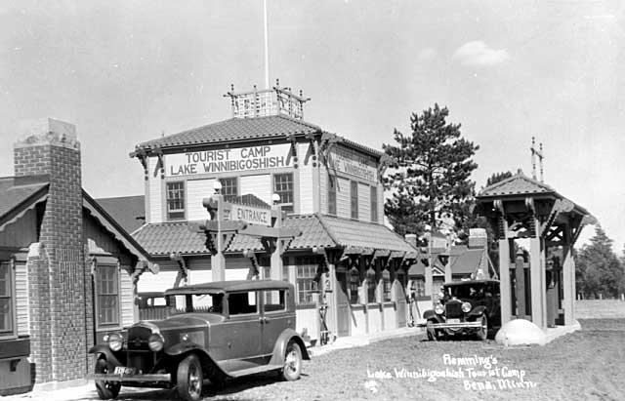
Flemming's Lake Winnibigoshish Tourist Camp, Bena
Photograph Collection, Postcard ca. 1925
Location no. MC3.9 BN r4
Minnesota Historical Society
Negative no. 101679
I said, "Well, ain't they got chickens anywhere else?"
I feed them chickens oats, ground food, and a mash--all that stuff. And if you had meat scraps, bread and toast, and stuff like that, they ate that too. I had as high as a hundred chickens there, and they were fat, too. They were fat! They were just yellow when you opened them, just yellow. I fed them corn, pure corn ground up. I'd buy that whole corn and grind it up. [If we make any money that way], I don't know. We made good, we kept even. I don't know what made money because I was logging besides.
[Move]
(9-33) When I got out of there I sold the place. My family wanted to go on that defense work for war time in forty-five, so I sold the place for four hundred bucks for the whole place. I still had money when I got out of there, but most of it was spent because I had paid my bills up for about four or five hundred.

Zzz

xxx [But pretty much, you might just as well say, I was pretty much just] roaming around between 1925 and ‘45. And when there was a potato rush there, and a beet rush, I would move back to Grand Forks. I worked up there for the American Crystal Sugar Beet Company when they were in season. And I did other spot work too. I did construction work around Grand Forks. I work in the potato [fields]. I picked potatoes.

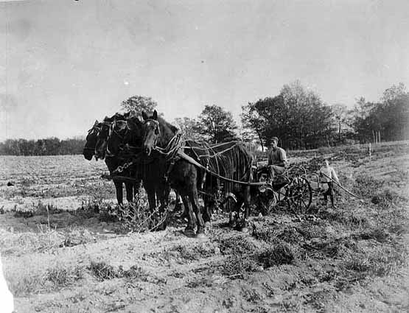
Horse-pulled potato digging machine, North Dakota
Photograph Collection ca. 1918
Location no. SA4.54 p15
Negative no. 780
Minnesota Historical Society
When the sugar beet factory was ready for processing sugar, I would work for them.
xxx
See, I was on the bundle team too. Xxx A bundler, a binder, [ties the oats into little bundles]. [The thresher] that threshes the oats off of the stock. With the thresher the stalks would] fall down and scatter out for fertilization, but the binder takes the grain [and the stocks] all in, so it's sorted. xxx A binder is the bundler so it sticks together. zzz At first all I had to do was drive the horses. They were good teams, and they were nice and fat! When I drove team I look at them. They got short of labor for a while. The laborers went further north. Well, then I had to jump off and tie my line where I could catch them if the horses jumped. We had lively teams, you know.

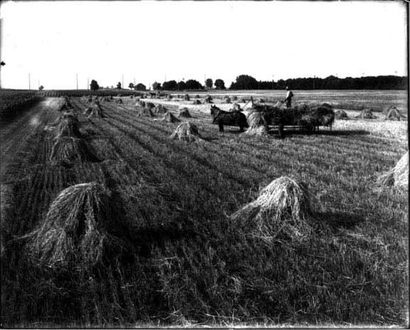
Picking up shocks of grain
Photograph Collection ca. 1910
Location no. SA4.52 p113
Negative no. 9628-B
Minnesota Historical Society

zzzXxx
After awhile, then, there were lots of people that went out there to get work. And when you got by the borderline you got lots of work. You bet we got work! When you got to Crookston you got lots of work because the labor there moved out west to get more wages. See? The wages took the people of the Crookston area. See, the other laborers were moving west, and we were moving out there. We were moving along with them, but behind them. This is west of Crookston, oh, about thirty, twenty-five, thirty miles west of Crookston. By the time you get to Crookston you would have money, and the further north [west] you went, the more wages you got. Once you made it west of Crookston we got about eighteen or twenty dollars a month. [That was pretty good money them days.]

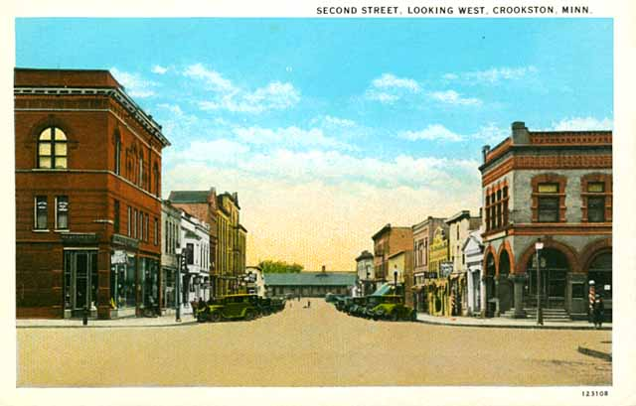
Second Street, looking west, Crookston.
Photograph Collection, Postcard ca. 1925
Location no. MP7.9 CR2 r20
Minnesota Historical Society

[78-11] Paul, we're on [tape] 41, [page] 10 here, and you say you We were shocking oats around Crookston. They had a little oats and farms around Crookston, but the further north [west] you went the more grain they had. Well, They had the bigger the fields north and west of there. xxx[27-36] And they change the crops around continually, otherwise the ground will wear out. XxxThat's why in Dakota they change their crops about. You plant there one year, you plant the other place the other year.
But those chemicals! If you put too much on your crops the chemical will burn them out. That chemical's too hot. But they say they have to use that chemical. What are you going to do with potato bugs and all that? All the insects come if you don't use chemicals.
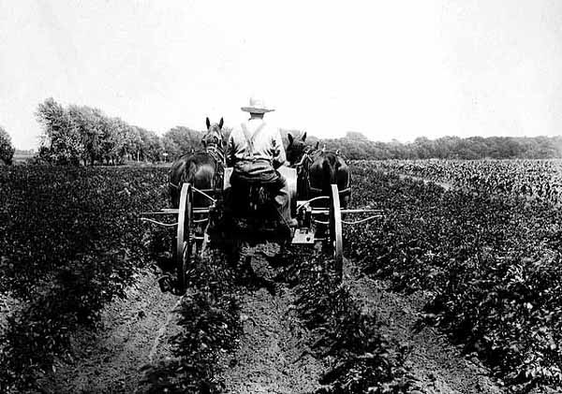
Spraying for potato bugs.
Photographer: Harry Darius Ayer (1878-1966)
Photograph Collection ca. 1910
Location no. SA4.9 r12
Negative no. 59069
Minnesota Historical Society]

xxx One time [, when I was living at Bena,] I got a letter that said, "You're not paying on Social Security." [As I was telling,] I was logging on my own, cutting timber on my own, at that time. "You're not putting in any money for your Social Security. You're late."
xxx(72-27) That was [about nineteen forty, forty-one.] about nineteen-twenty, twenty-one, when I got the letter that said you're not paying in Social Security. I was logging, that's why I got it. I was buying timber and logging. They found out I was buying timber. "So you're not paying any Social Security?"
[At that time I though] "I'm not eligible, 'cause...."
Xxx I was logging Bena, Minnesota. I was self-employed and had to pay out money to the men that worked for me. And I didn't have hardly enough to get by on because the value of the timber was too low. And [the cost of] labor was moving up. But anyhow I got enough timber, and I got enough money to get by with food and feed for my horses, at Bena, Minnesota.
xxx(57-1) Indian people were a little less interested in signing up for Social Security. Xxx The Indians didn't want to sign up so fast [for Social Security] because they thought all they were interested in was game and fish. That's included [in our way of thinkin’ about makin’ a living]. See, we go out to work. We go out to work and pick up a little sack of potatoes, or we work on the farm, shock a little bit, and then I go in the woods.
(57-3) We go in the woods later on [when we’re done working on a job], and then do a lot of hunting. But I don't think they [Indians] believe in holding a job year-round because too much was taken out of [in] the book.
[dup][4-19] [And] That's just the way I worked.[end dup]
Zzz So I didn't approve Social Security. That's why I was self-employed -- because I figured, "later on in years it might be too much red tape and I don't have a bookkeeper."
So [But] I came to find out that the Social Security was planning [or claiming? or?] on being the most helpful thing to the people.
Xxx(10-56) [And then I began thinking to myself,] “Whatever I asked my government, they done for me. “ “Whenever I asked the white people, they helped me. They knew all Indians were having a hard time getting improvements, so they did all they could. “
We was getting along well working, all of us picking berries in the summer because we knew winter was just around the bend. We was equal, same as the whites there.
Finally, when the War broke out, different laws come up and I had to go to Grand Forks and work. So, I went to Grand Forks and worked.
(10-56) I worked there and then War come on [WWII][ pretty strong]. Just about the time the War come there was a big sleet that poked the trees all over. We had to clean them out. Gee, we made good money. [ref Mark W. Seeley. Minnesota Weather Almanac. 2006. St. Paul, MN: Minnesota Historical Society Press, pp. 101-102]
Zzz
xxx
[Back at Bena Minnesota] (9-34) I paid them [my workers] up, squared up, and I moved out. xxx(9-33) When I got out of there I sold the place. My family wanted to go on that defense work for war time in forty-five, so I sold the place for four hundred bucks for the whole place. I still had money when I got out of there, but most of it was spent because I had paid my bills up for about four or five hundred.
Zzz Then I went to work on this Social Security plan. When I lived in Bena I was self-employed and I wasn't paying anything. I got a letter saying I wasn't paying, so I had to go out and go to work and pay on that Social Security plan. That's what destroyed my interest of farming [for myself]. I thought well, I'll go on my Social Security plan. It sounds good. I read up on it and it sounded good. By golly it's a good thing I went on it anyway. That's why I let the farm go. I should have turned my place over to the woman or the boys, but they didn't want to farm. The boys were big enough, but [at that time they weren’t interested in farming and later on] they wanted to go out [and] get on with defense plants. xxx My family wanted to go on that defense work for war time[, later on,] in forty-five.zzz
(57-2) So in order to make it [make minimum time for Social Security] I decided I'd move. I decided to sell out my place in Bena. I moved to Grand Forks for the bigger industries, and that's American Crystal Sugar Beet Company. That's when I went to work for American Crystal Sugar Beets of Grand Forks. Zzz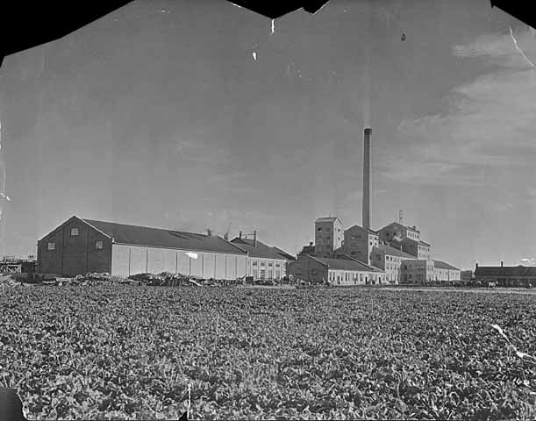
American Beet Sugar Factory, East Grand Forks.
Photographer: St. Paul Dispatch
Photograph Collection 1930
Location no. MP7.9 EG p4
Minnesota Historical Society
Xxx Right now I sold everything and dropped everything and went west. I got in working on a sugar beet plant for American Crystal. That's where they were paying Social Security. That's what I'm drawing now. xxx By golly it's a good thing I went on it anyway. zzz I'm thankful I helped myself to do that. It took a lot of sufferage to go in there and go through that, but still I got there. I got there, and now I can say I'm free. I can say I made it.

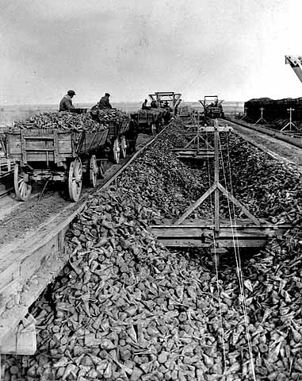
Sugar beet loading.
Photograph Collection ca. 1925
Location no. SA4.9 p41
Negative no. 20850
Minnesota Historical Society
zzz
(57-2) So in order to make it [make minimum time for Social Security] I decided I'd move. I decided to sell out my place in Bena. I moved to Grand Forks for the bigger industries, and that's American Crystal Sugar Beet Company. I think I worked there four or five years. All that time I had three or four to take care of. When I was employed [there] I was dependent. I had three or four dependents and when they took over a hundred dollars out of my check for those three and four dependents, I used to kick. So the office clerk told me, "Won't that look good when you get old age, Paul?"
"Well I got four or five [or 45???] years to go yet [to make ‘er Social Security.].”
"That'll be a good-looking check when you get it. And that'll continue all your life, from there on."
So I'm glad they took mine right out.
And then I stayed there, working five or six years for American Crystal. And I was proud of what they were doing. They hired not only me. I had two boys who worked there. They were hired too. So we all made good, ya. xxxdup The boys were big [old] enough [to keep a job there], but [after the War started] they wanted to go out get on [and work] with defense plants.
zzz So Social Security is a great thing. They'd never disregard that. Social Security is a most helpful thing. It's a helpful thing as a community work. It's working with your people. It's community work.
(2-20a) By the advice of white people, by our leaders in our counties and everything I'm getting along all right. I got letters which used to say, "You are working for Social Security. Make your reports. Someday you're going to get 65, and you're going to get Social Security." [At first] I didn't think much of that, you know. I want to be self-employed. But I thought, "no I cannot go along without cooperation. I think I'll join the cooperation, and join and be employed by some concern so I'll make enough for Social Security," which I did. I thought of that two, three times. Finally I went out into big factories because I was concerned that I made enough through my employment to get along on in my later years. I figure I wouldn't go hungry again. But if you go along self-employed, without any cooperation, without listening to no advice, you might not be taken care of in your old age. I was going wrong all these years. But now I'll be in the cooperation [cooperative]. I was joining the people that's smart, the people that sees things for your betterment in the future. I think it's a great thing that I have sidetracked to the private companies. See, I felt I had to join the community's action. It's a community action to develop the area of this country of which I'm living in now. I enjoyed it, I made little Social Security, and I was getting to be 65. But you don't get enough on Social Security, I am sure that the people in your local, in your locality, are not going to let you down. They are going to see that you get enough, and that's a big thing that the whites have proved amongst the Indian. I do learn that. We always feel that. But a lot of the Indians won't give in and speak of that. They always got some complaint. But we have to go along as a community. We have to go along for betterment, which I believe in. If you see them making good, let 'em make good. If you can help, help. And if you cooperate, it'll reflect to you later on. You'll feel it. You'll feel that things are going along fine. Cooperation, I think, is a wonderful thing. If you cooperate then you got friends.
(38-6) Now the changes are coming. Now people are building up on Social Security. That's another good thing.
Advisory is another thing.

(9-34) I was out there about five years. That was [until] about 1945, ‘46. I worked out in the beet fields in the summer, and I helped American Crystal collect labor. We used to come down here [to Leech Lake] in big trucks and get labor from the Indians. We'd load idle Indians up on the trucks. They'd give them cabins out there and furnish them with groceries. All they had to do was plot out the beets, thin them. They made good money thinning beets up there! I think we got two dollars an acre, or two dollars a ton, or something like that. They made good, because they didn't have to pay out any rent or anything at all. Everything was there, but they always bought some groceries. All they paid for were their groceries. They worked in groups. See, I saw some of them go out of there with eight, nine hundred dollars in their pockets, just like nothing.
I used to get about twenty [Indians from around here to plot out the beets]. If somebody was idle and wanted to go, I'd give them something to do. We'd pick a lot of them up, a whole truck load, and take them out to North Dakota -- I had a driver. I had a driver, and I'd just take the book and go around picking these Indians up, talking to them and explaining things in Indian to them. I'd take them up to the sugar beet company, and they'd give me a slip telling us where to go to unload the families. We usually had two or three families, depending on how many were in the family and how much labor they wanted in each place.
The whole family would go there. Ya, the whole family would just lock up and go. They'd take their bedding, that's all. They'd leave their dishes. If they didn't have any, we'd get dishes up there from the American Crystal Sugar Beet Company.

Then [After a while] I got in with that company and I went to work in the plant. I was purifying, running that sugar purifier in that plant. Three of us worked there. Ya, I had good position with that company. They wanted me to go to Crookston when they started up in Crookston, but I said I didn't want any of that. I told them "I'm going home to where the fish and the deer are."
Oh, there was game out there, yes. A little old guy, a farmer, come to me one time and I said to him, "Gee, you got mallards in the Red River. Look at the mallards out there, big mallards."
He said, "You like mallards?"
"Ohh, yeah a lot!" And I said at the same time, "How many chickens you got?"
"Lots."
"You don't like mallards then?"
"No, I don't care for 'em."
"You eat chickens?"
"I don't care for them either, because I get tired of 'em."
"How many chickens you got?"
"I don't know," the farmer said. "You like mallards?"
We were talking over by my cabin. "Ya, I like mallards."
"I got a twelve gauge Winchester over to the house. You could use it if you wanna."
He brought some shells, a box of shells, and his twelve gauge.
"Go get your mallards."
The river, the Red River, went through right on his place. We went down towards the river and shot three, four, of them mallards coming out of there. We shot them down. I don't know whether they were tame or wild, but they were big. Yes. We got the mallards and cooked them up.
"By gosh," I said, "I'll never shoot another bunch like that again. Those aren't like our mallards down home where we come from."
The woman said, "Why? Did you think they taste muddy, boggy, mucky, musky?"
"Yes."
‘Those mallards, they're on dead water. That's all they live on, those bugs you know."
Oh there was an awful taste to them. You couldn't eat it, it was so strong. I didn't like it. It wasn't like our free-water mallards here. No, the mallards here are good, ya.
"No," I said, "I won't shoot another bunch."
I told the farmer that.
"Well," he said, "there's a lot of ducks, but they don't eat 'em because they don't taste good. You see, we tried 'em. We don't like 'em. They don't taste good here. They eat bugs on that dead water in there. There's dead logans in there." So he said to me, "I'll get you some feeding birds."
When he went home he got a half-a gunnysack full of chickens. Oh, there were about eight or ten in there. He threw them on the ground and said, "There, you don't have to hunt ducks. That's chicken."

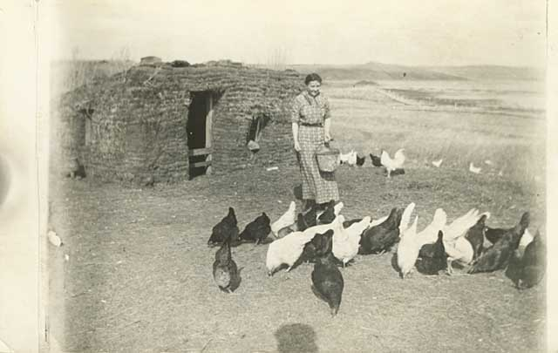
Woman feeding chickens by sod house, North Dakota.
Photograph Collection, Postcard ca. 1915
Location no. E200 r3
Negative no. 11083
Minnesota Historical Society

They were big chickens too. We let them run loose even though there was a chicken coop there. We lived on an old farm where he moved out of when he built a new house. He moved out of this house and into a new place. We let those chickens run, but we used that old chicken coop later on.
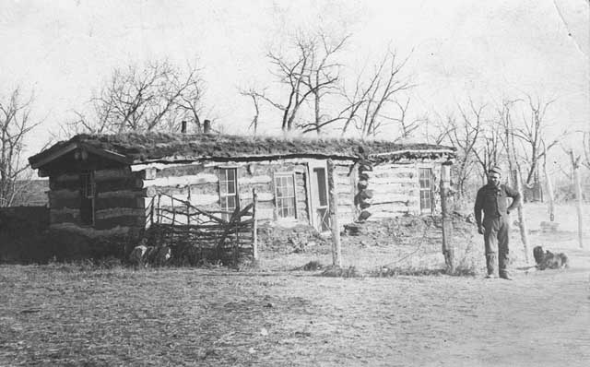
Pioneer North Dakota log house.
Photograph Collection, Postcard ca. 1910
Location no. E200 r68
Minnesota Historical Society

Believe me, we lived good out there. We lived good out there. Oh, they took good care of the Indians. That big company took care of the Indians good.

They had Mexicans working too, but we got along together.
(61-34) But you have to consider too that we're alive in the north, way in the north, so that doesn't make any difference. But in the south you could see a difference [physiologically]. When the southern people get up here and work on the [sugar] beets they have their earlaps down and their gloves on!
We're working in shirtsleeves.
He [One of the Southern people] says, "How can you guys stand it in the forty-below weather up here?"
"Why, we're natural born, we're naturalized to here."
(9-37) Yeah, we got along. Mexicans aren't a bad people. They're nice people. It's just how you use them, you know. They pull some young pranks that people expect, but everybody's young. They're young, but we got along good with them.
My boys played with a Mexican kid. They were about fourteen years old, fourteen, sixteen years old. They'd go out together in cars. I don't know what they did at night with them, but they'd go traveling, and visiting towns together. Sometimes they'd go to shows. When they'd come back, I'd ask them, "How can you get along with a Mexican? Do they drink?"
"Oh ya, they drink a little beer."
Ya, we got along good with that Texas bunch. There was a Texas bunch and an Indian bunch[, a National bunch.]
We got along good with both those bunches, but we were kind of scared of those Nationals. The Nationals didn't trust the Texas bunch.
The Nationals were the real Mexicans, the ones that come from Mexico. They had them up here too. The farmer hired Nationals, and I worked with Nationals in the American Crystal plant. We had kind of a rough time with them -- it wasn't really too rough, it was just that we had kind of a hard time trying to make them understand. See, I think the Mexico Mexicans felt like the farmers were ordering them too much. But no, it's the idea that the farmer wanted something, this work, done, and done properly -- and they couldn't understand. That's where the drawback was.
[They just talked Mexican,] and when one of them wanted to discuss something the leader would call in a translator. We had a field worker there who could translate. We had a worker in that office and the farmer'd tell the Mexican workers, "I'll have to get the field worker to come talk to you." Then they'd talk, "Baba, baba, baa-baah." They'd tease, you know, and they were ornery. They had their big knives too.
Pretty soon that big car we were watchin' come from the direction of the main office. Pretty soon the field worker'd come. He was the head man. He talked Spanish. He'd talk any language. The workers thought he was a Mexican. He [was] quite a dark-headed guy. Ha! He came out to the field and somebody said, "There's the field worker. There's the guy that's Mexican. He'll talk to you."
Gee, they all ran up to him. They took off their big hats and kneeled right down in front of him. They'd kneel down in the front of him, that's how they greeted him. They greet him that way. They kneel right in the front of him. They knelt down on one leg in the front of him. They all did that. He said something in Mexican to them, and boy they took off their hats. Oh geez! You could never get a better crew after they knew that guy was from the office, and after he told them that they had to do their work according to what the farmer told them. "You watch the farmer, and what he tells you to do, do it," he said. "You can't understand English, but do the best you can," he told them. Boy we had a good crew after that!
And how they'd fight in the trailer. Sometimes they'd move the men in a trailer. xxx They had about twenty, fifteen or twenty guys in the trailer. They had big long four-wheel trailers with wheels on. zzz The women got in the cars, and the men folks took the tractor with a big trailer and big box on it. Sometimes we had to get moved to a different field because it was quite a ways to walk. When it was a mile and a half or two we'd get into these trailers. The nationals and the Texas bunch would get mixed up sometime. It happened that way sometimes. The Nationals didn't have their cars, you know, because they were ordered by their government.
I asked one Mexican -- one National, one time, "How much you making here?"
"Don't know. Don't know," he said.
He didn't know. He got his money from the government down there when he got back. They'd haul them up here, and they haul them back. They got paid down there. The government did their business with the companies, but they took good care of them. I guess they got their money down in their country. Their dollar was valued in Mexico. Boy, when they'd get there they were rich with what they made here. There was a lot of value in there, in that silver dollar, when they'd get down to Mexico. When they got back down there the valuation of what they made up here is full value of what they're supposed to have. They were rich when they got in Mexico. That's why they came up here to work. So, that's the way it went.
I was going to tell you, we were riding that trailer and pretty soon three, four of them started to fight in there, right in the trailer. The one big leader went right in, pushed them apart, and talked Mexican to beat hell. It got so that tractor guy had to stop. After they finished, all started to laugh. After the fight stopped, they all started to laugh at one another. Even them two that were fighting started to laugh. That's how they got along.
They had their meat knife there with them. They didn't use them though. They would just push one another around. They'd just started pushing and wrestling in there. They might have used them too, if one gang busted in or started to break in. If they were to break out [with those knives], why I'd-a-been stepping outta the trailer and I'd-a run like heck.
Geez, I can remember that just as good as if I were right there. I laugh yet today about it, about how they went at it in there. They didn't go to blows, they just wrestled. I was afraid it might break out if we all joined in. The leader busted it up. The leader busted it up, and he had to talk to beat hell before they quit. Oh ya. I had some pretty husky boys, too, but they were in the back of me. One of them was pretty good, but I didn't want to get in there. Besides, we couldn't understand what they were fighting for. That was the best part of it; we didn't know anything about it. It was just between the Nationals and the Texans, but the Texans were more advanced. They had a little better education, and had a better understanding of the meaning of the union rules. The Texas bunch were nice fellas. We get along good with the Texas bunch. I like to set and visit with them. They'd come over to our place at times. When they'd catch us at meal times we'd cook up Indian bread and all that.
Boy they'd go for that fry bread. Oh boy! Oh geez that's good, ya. It's simple to make too. You just deep fry bread dough in grease, that's all. It's simple. You just take baking powder and add that to your flour. Fry bread's made from flour and baking powder, water, and salt. That's all. You just mix that together and deep fry it, yes. Boy that's good. Ya. That's what I call an Indian doughnut. Indian doughnuts! Ya, that's life. You don't know lots about this country they give us.

[4-19][duplicated] That's just the way I worked [in North Dakota].
I was out there about five years. After five years we got tired of working that area. There were all kinds of slopes coming in pretty fast. A slope is a pile of beets, piled up with a peak and slopes on the sides. [add image(s) here] When the sun would shine in [on] them the syrup would blister and run out. What I mean is that people would hear so much about that area, like seasonal work, and they'd move up there. Then there'd be a lot of people around here looking for jobs. The farmers were doing pretty good on their crops. The crops were good and they were short of labor. People would hear that and they'd rush up there. So I got to thinkin', "Well, I better try somethin’ else, naturally."
I always heard that Duluth was a good town too. So I moved to Duluth and I got a place there. [That was] about 1949. It was a place rented. We used a place there, and right away I had a job. I went to Duluth, Iron and Globeworks. Duluth Ironworks Globe. I worked there about four or five years, four or five winters.
That'd be about 1948 or '50. Around fifties. Then I moved to Superior. I was getting better money over there in Superior. I got over to the Acme Iron Works. I worked there for Campbell, the banker's son. The two companies were kinda working together. I liked that line of iron work, like molding. I didn't mold, but I was a finisher. I worked finishing off the casting that come through the iron works. I was a finisher on the cast iron. Then I would grade the metal which we'd remelt.

Duluth is also where we had the uprising in the Indian office.

