The Role of Flow Sensing by the Lateral Line System in Prey Detection in Two African Cichlid Fishes

Margot A.B. Schwalbe, PhD

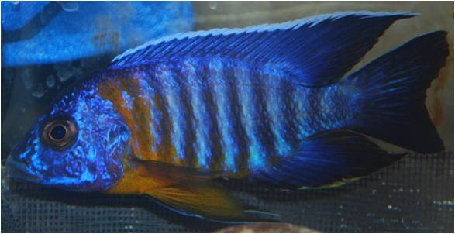
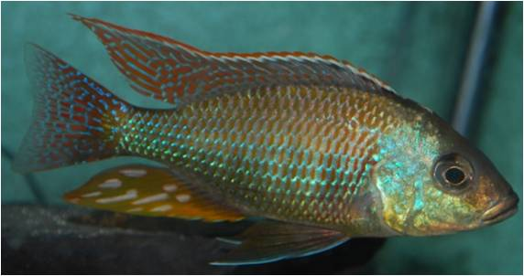
The mechanosensory lateral line system is found in all fishes and is used to detect water flows, including flows generated by mobile prey. Of the five cranial lateral line canal patterns found in fishes, widened canals are assumed to be an adaptation for prey detection but few studies have directly tested this in a comparative context. African peacock cichlids, Aulonocara, have widened canals, while another closely related cichlid, Tramitichromis, has narrow canals, but both feed on benthic invertebrates. The relative roles of the lateral line system and vision in prey detection in these two species were assessed using two independent behavioral assays: 1) by presenting fish with either “benthic,” natural prey (tethered brine shrimp), and 2) using artificial stimuli generated by a novel stimulus delivery system under light or dark conditions. This work has established Lake Malawi cichlids as model system for the study of the sensory basis for prey detection behavior using both natural and artificial stimuli under different environmental conditions.
Aulonocara stuartgranti
Tramitichromis sp.

